“Design and Development of an Integrated Tourism Platform for Flights, Trains, Hotels, and Hidden Destinations”
A Project Report Submitted in the partial fulfillment of the requirements for the award of the degree of

BACHELOR OF TECHNOLOGY
In

DEPARTMENT OF COMPUTER SCIENCE ENGINNERING
&
DEPARTMENT OF COMPUTER SCIENCE AND INFORMATION TECHNOLOGY
By

T. SAI SRI PARINITA 2520030562
P. ANURADHA NANDINI 2520030171

Under the Esteemed Guidance of

Dr Pavithra Duggineni
Assistant Professor
Department of Computer Science and Engineering




K L (Deemed to be) University DEPARTMENT OF COMPUTER SCIENCE ENGINEERING
&

DEPARTMENT OF COMPUTER SCIENCE AND INFORMATION TECHNOL



Declaration

The Project Report entitled “Design and Development of an Integrated Tourism Platform for Flights, Trains, Hotels, and Hidden Destinations” is a record of Bonafide work of T.SAI SRI PARINITA - 2520030562 , P. ANURADHA NANDINI – 2520030171 submitted in partial fulfillment for the award of B. Tech in Computer Science and Engineering (or) Computer Science and Information Technology to the K L University. The results embodied in this report have not been copied from any other departments/University/Institute.

T. SAI SRI PARINITA – 2520030562

P.ANURADHA NANDINI-2520030171

K L (Deemed to be) University

DEPARTMENT OF COMPUTER SCIENCE ENGINEERING

&

DEPARTMENT OF COMPUTER SCIENCE AND INFORMATION TECHNOLOGY



CERTIFICATE

This is certify that the mini project based report entitled“Design and Development of an Integrated Tourism Platform for Flights, Trains, Hotels, and Hidden Destinations” is a bonafide work done and submitted by T. SAI SRI PARINITA - 2520030562 , P. ANURADHA NANDINI - 2520030171 in partial fulfillment of the requirements for the award of the degree of BACHELOR OF TECHNOLOGY in Department of Computer Science Engineering, K L (Deemed to be University), during the academic year 2025-2026.

Signature of the Guide

Signature of the Course Coordinator Signature of the HOD

ACKNOWLEDGEMENT
The success in this project would not have been possible but for the timely help and guidance rendered by many people. Our wish to express my sincere thanks to all those who has assisted us in one way or the other for the completion of my project.

Our greatest appreciation to my Course Coordinator Dr Madhavi Karumudi, and my guide Dr Pavithra Duggineni, Department of Computer Science which cannot be expressed in words for his/her tremendous support, encouragement and guidance for this project.

We express our gratitude to Dr. Chaithanya Kumar (CSE), Head of the Department for Computer Science Engineering for providing us with adequate facilities, ways and means by which we are able to complete this project-based Lab.

We thank all the members of teaching and non-teaching staff members, and also who have assisted me directly or indirectly for successful completion of this project. Finally, I sincerely thank my parents, friends and classmates for their kind help and cooperation during my work.

T. SAI SRI PARINITA – 2520030562

P. ANURADHA NANDINI – 25200301781

Abstract

The rapid growth of entrepreneurship and startup culture has transformed the way educational institutions encourage innovation among students. Colleges and universities are increasingly establishing Innovation and Startup Cells to support aspiring entrepreneurs by providing mentorship, incubation opportunities, technical guidance, and access to startup resources. However, managing startup-related activities through conventional methods such as manual documentation, spreadsheets, emails, and disconnected software often leads to inefficiencies, communication gaps, and difficulties in monitoring startup progress.

The Student Innovation & Startup Cell Portal is a comprehensive web-based platform developed to digitize and simplify the complete startup management process within an educational institution. The system provides a centralized environment where students can register startups, submit innovative business proposals, connect with mentors, develop Minimum Viable Products (MVPs), prepare for investor pitches, participate in Demo Day events, and monitor the overall progress of their entrepreneurial journey. Simultaneously, administrators are provided with a powerful management dashboard to oversee startups, proposals, mentors, users, and institutional startup activities through an intuitive interface.

One of the most innovative features of the proposed system is the AI-Powered Pitch Readiness Checker. This module utilizes Google's Gemini API to intelligently analyze startup ideas and evaluate their readiness for incubation programs, startup competitions, and investor presentations. The AI evaluates seven important business parameters, namely Team Readiness, Business Clarity, Innovation Level, Market Potential, Solution Strength, Problem Definition, and Business Model Viability. Based on this evaluation, the system generates an overall readiness score, detailed feedback, strengths, weaknesses, and personalized recommendations that help students improve the quality of their startup pitches before presenting them to mentors or investors.

The application has been developed using modern web technologies including React, TanStack Start, TypeScript, Tailwind CSS, Supabase, PostgreSQL, and Google Gemini API. Google OAuth authentication has been integrated to provide secure and convenient user login, while Supabase manages authentication, database operations, and backend services. The responsive user interface ensures seamless accessibility across desktop and mobile devices.

The portal consists of separate interfaces for students and administrators. Students can efficiently manage startup activities through modules such as Dashboard, My Startup, Proposal Submission, Mentor Connect, Pitch Preparation, MVP Management, Demo Day, and the AI-Powered Pitch Readiness Checker. Administrators can monitor startup registrations, review proposals, assign mentors, manage users, publish success stories, and analyze startup progress through a centralized administrative console.

The primary objective of this project is to create a digital ecosystem that encourages innovation, entrepreneurship, and startup development within educational institutions while reducing manual administrative efforts. By integrating Artificial Intelligence with startup management, the proposed system provides students with intelligent decision support that significantly enhances their preparation for entrepreneurship and incubation opportunities.

The Student Innovation & Startup Cell Portal not only simplifies startup administration but also creates an interactive platform that bridges the gap between students, mentors, and administrators. The system promotes transparency, collaboration, and continuous learning while preparing students to become successful entrepreneurs capable of contributing to the rapidly growing startup ecosystem.

Index

S.  No. | Chapters | Topics | Page.no
 |  | Acknowledgement
 |  | Abstract
1 | Introduction | - Background of the project  - Problem statement  - Scope of the project  - Objective(s)  - Importance of the application  - Target users/audience | 5-15
2 | System Requirements | - Hardware requirements  - Software requirements  - Development tools and frameworks | 16-21
3 | Technology Stack | - Front-end (e.g., React.js, Angular, HTML/CSS)  - Back-end (e.g., Node.js, Django, Spring Boot)  - Database (e.g., MongoDB, MySQL, PostgreSQL)  - Version Control (e.g., Git, GitHub)  - APIs or External services (e.g., Firebase, Stripe) | 22-32
4 | System Architecture | - High-level architecture diagram  - Description of each layer (frontend, backend, database)  - Deployment architecture (e.g., cloud, local, CI/CD  pipelines) | 33-36
5 | Design | 5.2 ER Diagram / Database schema | 37
6 | Implementation | - Module-wise implementation  - Front-end logic (UI rendering, state management)  - API integration  - Authentication & Authorization | 38-47
7 | Features | - List of main features  - How each feature works (user perspective + technical description) | 48-55
8 | Testing | - Postman testing (frontend/backend)  - Integration testing  - Tools used for testing  - Test cases and results | 56-64
9 | Deployment | - Steps to deploy  - Environment configuration  - Hosting of frontend and backend | 65-73
10 | Challenges & Limitations | - Issues faced during development  - Solutions applied  - Current limitations or known bugs | 74-82
11 | Future Enhancements | - Planned features  - Possible integrations or optimizations | 83-88
12 | Conclusion | - Summary of the project  - What was achieved  - Skills learned during development | 89-97
13 | References | - Books, tutorials, APIs, documentation sites used | 98-99

14 | Appendices | - Screenshots of the app  - Sample code snippets  - Installation/setup instructions  - User manual or guide  -Geo Tag photos with guide  -Review forms with guide signatures | 100-105

CHAPTER -1 INTRODUCTION

Background of the Project

Entrepreneurship has emerged as one of the most significant contributors to technological advancement, economic development, and employment generation across the world. In recent years, educational institutions have recognized the importance of cultivating entrepreneurial thinking among students by establishing Innovation and Startup Cells that encourage creativity, research, and business development. These dedicated cells serve as incubation centers where students receive guidance, mentorship, infrastructure support, and opportunities to transform innovative ideas into viable business ventures.

With the rapid growth of startup ecosystems in countries such as India, educational institutions are increasingly becoming the birthplace of innovative products and technology-driven businesses. Government initiatives such as Startup India, Atal Innovation Mission, and various university incubation programs have further strengthened the culture of innovation by providing funding opportunities, mentorship, and policy support for student entrepreneurs. As a result, colleges are expected to maintain structured startup ecosystems that efficiently manage startup registrations, proposal evaluations, mentor assignments, incubation activities, and progress monitoring.

Despite these developments, many institutions continue to rely on conventional methods such as manual paperwork, email communication, spreadsheets, and isolated software tools for managing startup-related activities. These fragmented processes often create communication gaps between students, mentors, and administrators. Startup records become difficult to maintain, proposal evaluation takes longer, mentor assignments lack transparency, and tracking the overall progress of startups becomes increasingly complicated. Furthermore, students often receive limited guidance during the early stages of startup development due to the absence of a centralized collaboration platform.

The need for digital transformation within educational startup ecosystems has therefore become increasingly important. A centralized web-based portal can eliminate these challenges by integrating all startup-related activities into a single platform. Such a system enables seamless interaction among students, mentors, and administrators while ensuring transparency, accessibility, and efficient management of startup information.
The Student Innovation & Startup Cell Portal has been developed with this objective in mind. It serves as a comprehensive digital ecosystem that supports the complete startup incubation lifecycle within an educational institution. Through this portal, students can register their startups, submit innovative business proposals, prepare for incubation programs, interact with mentors, participate in institutional startup initiatives, and monitor the progress of their entrepreneurial journey.

Unlike conventional startup management systems, the proposed platform also incorporates an AI-Powered Pitch Readiness Checker, which represents one of the most innovative aspects of the project. This intelligent module utilizes Google's Gemini API to analyze startup pitches across multiple business dimensions, including Team Readiness, Business Clarity, Innovation Level, Market Potential, Solution Strength, Problem Definition, and Business Model Viability. Based on these evaluations, the system generates an overall readiness score along with detailed feedback and actionable recommendations. This allows students to refine their ideas and improve their presentation skills before approaching mentors, investors, or incubation centers.

The portal follows a role-based architecture that supports two primary user categories: students and administrators. Students can manage startup activities through dedicated modules such as My Startup, Proposal Submission, Mentor Connect, Pitch Preparation, MVP Development, Demo Day participation, and the AI-Powered Pitch Readiness Checker. Administrators, on the other hand, are provided with a comprehensive management console that enables them to oversee startup registrations, evaluate proposals, assign mentors, manage users, publish success stories, and monitor institutional startup activities through a centralized dashboard.

The system has been developed using modern web technologies, including React, TanStack Start, TypeScript, Tailwind CSS, Supabase, and Google's Gemini API. These technologies ensure high performance, scalability, security, and responsiveness across multiple devices. Google OAuth authentication further enhances user convenience by providing secure login functionality without requiring separate account registration.
Overall, the Student Innovation & Startup Cell Portal represents a modern digital solution that bridges the gap between academic innovation and entrepreneurial development. By combining startup management with artificial intelligence, mentorship support, and centralized administration, the portal creates an environment that encourages students to transform innovative ideas into successful entrepreneurial ventures while simplifying the operational responsibilities of educational institutions.

Problem Statement

The rapid growth of entrepreneurship and startup culture has encouraged educational institutions to establish Innovation and Startup Cells that promote creativity, research, and business development among students. These startup cells act as incubation centres where students receive mentorship, technical guidance, funding opportunities, and institutional support to transform innovative ideas into successful business ventures. However, despite the increasing emphasis on innovation and entrepreneurship, the management of startup-related activities within many educational institutions remains largely fragmented and inefficient.

In many colleges, startup registration, proposal submission, mentor allocation, startup evaluation, and progress monitoring are still performed using conventional methods such as physical documentation, spreadsheets, email communication, and multiple independent software applications. These disconnected systems create difficulties in maintaining accurate records, increase administrative workload, delay decision-making processes, and reduce transparency between students, mentors, and administrators. As the number of student startups increases, managing these activities manually becomes increasingly complex and time-consuming.

Students often face challenges throughout their entrepreneurial journey due to the absence of a centralized digital platform. Startup information is scattered across multiple records, proposal submissions are difficult to track, mentor assignments are not always transparent, and important announcements or updates may not reach all stakeholders efficiently. Furthermore, students frequently encounter difficulties in monitoring the status of their proposals, incubation applications, mentorship sessions, and startup milestones, resulting in poor communication and reduced engagement.

Another significant challenge is the lack of structured guidance during startup pitch preparation. Many student entrepreneurs possess technically innovative ideas but struggle to present their business concepts effectively to mentors, investors, or incubation centres. Preparing a successful startup pitch requires careful evaluation of various factors such as business clarity, market opportunity, innovation potential, problem definition, team preparedness, solution feasibility, and business model viability. Existing startup management systems primarily focus on administrative functions and do not provide intelligent mechanisms for evaluating startup readiness before formal presentations.

As a result, students often receive feedback only after presenting their ideas to mentors or investors. This delayed feedback increases the number of revisions required, reduces confidence during presentations, and may cause promising startup ideas to be overlooked. There is therefore a growing need for an intelligent support system capable of analyzing startup ideas, identifying weaknesses, and providing constructive recommendations before students participate in startup competitions, incubation programs, or investor meetings.

Administrative departments also encounter several operational challenges. Reviewing numerous startup proposals manually consumes considerable time and effort. Assigning suitable mentors based on startup domains becomes difficult without centralized information. Maintaining historical startup records, monitoring startup growth, generating institutional reports, and publishing startup success stories require significant manual intervention, thereby affecting the overall efficiency of the Startup Cell.

Another important concern is data security and accessibility. Manual records are susceptible to data loss, duplication, and inconsistencies, while disconnected systems make it difficult to ensure secure access control and reliable information management. Educational institutions require a secure, scalable, and centralized digital platform capable of maintaining accurate startup records while providing role-based access to students, mentors, and administrators.

To overcome these challenges, the proposed Student Innovation & Startup Cell Portal introduces a comprehensive web-based solution that integrates startup registration, proposal management, mentor allocation, startup progress tracking, administrative management, and AI-assisted startup evaluation into a single platform. The system eliminates fragmented workflows by providing a centralized repository of startup information that can be accessed securely by authorized users.

A key innovation of the proposed system is the AI-Powered Pitch Readiness Checker, which leverages Google's Gemini API to evaluate startup pitches based on seven critical business parameters: Team Readiness, Business Clarity, Innovation Level, Market Potential, Solution Strength, Problem Definition, and Business Model Viability. The AI-generated readiness score, detailed feedback, and personalized improvement suggestions enable students to refine their business ideas before approaching mentors or investors, thereby improving the overall quality of startup presentations.

By digitizing startup management processes and integrating artificial intelligence into entrepreneurial support, the proposed system aims to improve operational efficiency, enhance collaboration, simplify administrative tasks, promote innovation, and create a more effective startup ecosystem within educational institutions.

Scope of the Project

The Student Innovation & Startup Cell Portal is designed as a comprehensive web-based platform that supports the complete startup lifecycle within an educational institution. The scope of the project extends beyond simple startup registration by integrating multiple services that assist students, mentors, and administrators throughout the entrepreneurial journey. The system provides a centralized environment where startup-related activities can be managed efficiently through a secure and user-friendly interface.

The primary scope of the project is to digitize the operations of the institution's Innovation and Startup Cell by replacing traditional manual processes with an integrated online platform. Students can register their startup ideas, submit business proposals, manage startup information, communicate with mentors, prepare for startup pitches, monitor project progress, develop Minimum Viable Products (MVPs), and participate in Demo Day activities through a single application. This centralized approach eliminates the need for maintaining multiple records across different platforms and significantly improves operational efficiency.

The portal also provides a dedicated administrative dashboard that enables Startup Cell coordinators to manage startup registrations, review proposals, assign mentors, monitor startup progress, publish success stories, and maintain user information. Administrators can efficiently oversee institutional startup activities through role-based access controls while maintaining complete transparency throughout the startup incubation process.

One of the most significant aspects of the project's scope is the integration of the AI-Powered Pitch Readiness Checker. This intelligent module analyzes startup ideas submitted by students and evaluates their readiness for incubation programs, startup competitions, or investor presentations. The AI evaluates multiple business dimensions including Team Readiness, Business Clarity, Innovation Level, Market Potential, Solution Strength, Problem Definition, and Business Model Viability. Based on this evaluation, the system generates an overall readiness score, highlights areas requiring improvement, and provides personalized recommendations that assist students in strengthening their startup pitches before presenting them to mentors or investors.

The project also includes secure authentication using Google OAuth, ensuring that only authorized users can access the portal. Role-based authorization differentiates the functionalities available to students and administrators, thereby maintaining system security and protecting sensitive startup information. The responsive user interface enables users to access the portal from desktops, laptops, tablets, and mobile devices without compromising usability or performance.

From a technical perspective, the system has been developed using modern web technologies such as React, TanStack Start, TypeScript, Tailwind CSS, Supabase, PostgreSQL, and Google Gemini API. These technologies provide scalability, maintainability, security, and excellent performance, making the platform suitable for deployment in educational institutions with a growing number of users.

Although the current implementation primarily focuses on serving Startup Cells within colleges and universities, the overall architecture has been designed to support future expansion. The platform can be extended to include investor networking, startup funding management, intellectual property tracking, patent management, mentor communication systems, mobile applications, advanced analytics dashboards, and AI-driven startup recommendations. Such enhancements would further strengthen the platform as a complete entrepreneurship management ecosystem capable of supporting innovation beyond the academic environment.

Objectives of the Project

The primary objective of the Student Innovation & Startup Cell Portal is to develop a centralized, secure, and intelligent web-based platform that promotes entrepreneurship and innovation within educational institutions by simplifying startup management and providing students with comprehensive digital support throughout their entrepreneurial journey.

The specific objectives of the project are as follows:
- To develop a centralized online platform for managing all startup-related activities within an educational institution.
- To enable students to register their startup ideas digitally without relying on manual paperwork or offline documentation.
- To provide an efficient proposal submission system that allows students to submit innovative business ideas and business plans electronically.
- To establish a structured mentor management system that facilitates effective interaction between students and assigned mentors.
- To provide administrators with a comprehensive dashboard for monitoring startup registrations, proposals, mentor assignments, and overall startup activities.
- To simplify the startup incubation process by maintaining organized digital records of every startup throughout its lifecycle.
- To enable students to monitor the status of their startup proposals, mentor interactions, and incubation progress through personalized dashboards.
- To implement secure authentication and role-based authorization using Google OAuth and Supabase Authentication for protecting user information and startup data.
- To integrate an AI-Powered Pitch Readiness Checker capable of evaluating startup pitches using Artificial Intelligence before students present them to mentors or investors.
- To generate detailed AI-based evaluation reports that measure startup readiness based on Team Readiness, Business Clarity, Innovation Level, Market Potential, Solution Strength, Problem Definition, and Business Model Viability.
- To provide constructive AI-generated feedback and recommendations that help students improve their startup ideas and presentation quality.
- To develop a responsive and user-friendly interface that provides seamless accessibility across desktop, laptop, tablet, and mobile devices.
- To reduce administrative workload by automating startup registration, proposal management, mentor allocation, and startup monitoring processes.
- To encourage innovation and entrepreneurship by creating a collaborative digital ecosystem connecting students, mentors, and administrators.
- To develop a scalable system capable of supporting future enhancements such as investor networking, startup funding management, advanced analytics, mobile applications, and additional AI-driven entrepreneurial support.

By accomplishing these objectives, the proposed system aims to create a modern, efficient, and intelligent startup management platform that supports innovation while improving the operational efficiency of educational institutions.

Importance of the Application

Innovation and entrepreneurship have become essential components of modern education, encouraging students to apply their technical knowledge to solve practical problems while creating sustainable business opportunities. Educational institutions across the country are actively promoting startup culture by establishing Innovation and Startup Cells that provide mentorship, incubation support, and entrepreneurial guidance. However, the absence of integrated digital management systems often limits the effectiveness of these initiatives. The Student Innovation & Startup Cell Portal addresses this need by providing a centralized platform that simplifies startup management while enhancing collaboration between students, mentors, and administrators.

One of the most important contributions of the application is the digitization of startup management processes. Traditional manual methods involving paperwork, spreadsheets, and email communication are replaced by an integrated online platform where all startup information is securely maintained. This significantly reduces administrative effort, minimizes errors, improves transparency, and accelerates decision-making.

The application serves as a comprehensive entrepreneurship management system by bringing together multiple startup-related services within a single platform. Students no longer need to use separate applications for startup registration, proposal submission, mentor communication, and progress tracking. Instead, every activity can be performed through one centralized dashboard, improving user convenience and operational efficiency.

The integration of Artificial Intelligence significantly increases the practical value of the application. The AI-Powered Pitch Readiness Checker provides students with intelligent analysis of their startup ideas before formal presentations. Rather than waiting for manual feedback from mentors, students receive immediate AI-generated evaluations that identify strengths, weaknesses, and opportunities for improvement. This intelligent guidance helps students prepare stronger business pitches, improve confidence, and increase their chances of success during startup competitions, incubation programs, and investor meetings.

The application also promotes transparency throughout the startup incubation process. Students can monitor proposal status, mentor assignments, startup milestones, and administrative updates in real time. Administrators, on the other hand, gain complete visibility into startup activities, enabling better planning, monitoring, and reporting.

Another important aspect of the application is its scalability and flexibility. The platform has been developed using modern web technologies that support future expansion. Additional features such as investor networking, startup funding management, patent tracking, mobile applications, analytics dashboards, and advanced AI services can be integrated without requiring significant architectural changes.

The responsive design of the application ensures accessibility across multiple devices, allowing users to manage startup activities anytime and anywhere. Secure authentication using Google OAuth enhances user convenience while maintaining strong security standards for institutional data.

From an educational perspective, the platform encourages students to develop entrepreneurial thinking by providing structured guidance throughout the startup development process. Instead of focusing only on startup registration, the application supports students from idea generation to pitch preparation, thereby creating a complete entrepreneurial learning environment.
Overall, the Student Innovation & Startup Cell Portal serves as a modern digital ecosystem that not only improves institutional efficiency but also empowers students to transform innovative ideas into successful entrepreneurial ventures through technology, collaboration, mentorship, and Artificial Intelligence.

Target Users / Audience

The Student Innovation & Startup Cell Portal has been developed to serve multiple categories of users within an educational institution. Each user group interacts with the system according to its specific responsibilities and access privileges. Role-based access control ensures that users can access only the functionalities relevant to their responsibilities while maintaining data security and system integrity.

1. Students
Students constitute the primary users of the application. They utilize the portal to register innovative startup ideas, submit business proposals, communicate with mentors, participate in incubation activities, monitor startup progress, prepare Minimum Viable Products (MVPs), participate in Demo Day events, and evaluate their startup pitches using the AI-Powered Pitch Readiness Checker.
The personalized student dashboard provides quick access to startup information, proposal status, mentorship details, upcoming activities, and AI-generated pitch evaluation reports. By offering all startup-related services through a single interface, the system simplifies the entrepreneurial journey for students while encouraging innovation and collaboration.

2. Startup Cell Administrators
Administrators are responsible for managing the overall operation of the Startup Cell. Through the administrative dashboard, they can review startup registrations, evaluate proposals, assign mentors, manage startup records, publish success stories, oversee user accounts, and generate reports for institutional monitoring.
The centralized administrative console significantly reduces manual workload while improving transparency, accountability, and efficiency in startup management activities.

3. Mentors
Although mentor management is primarily controlled by administrators, mentors also benefit from the platform by receiving structured information about assigned startups. They can review startup proposals, understand business objectives, monitor student progress, and provide guidance based on startup development stages.
The centralized availability of startup information improves communication between mentors and students while ensuring continuous entrepreneurial support.

4. Educational Institutions
Colleges, universities, and innovation centres represent another important target audience. The platform enables educational institutions to establish a professional digital startup ecosystem capable of managing entrepreneurship programs efficiently. Institutional administrators can monitor startup activities, evaluate program effectiveness, maintain digital records, and generate reports for accreditation, funding agencies, and government initiatives.

5. Future Stakeholders
The architecture of the application has been designed to support future expansion. Additional stakeholders such as investors, incubation centres, startup accelerators, alumni entrepreneurs, industry experts, and government agencies can be integrated into the platform through future enhancements. This scalability enables the portal to evolve into a comprehensive entrepreneurship ecosystem that supports collaboration beyond the academic environment.
In summary, the Student Innovation & Startup Cell Portal has been designed to serve students, administrators, mentors, and educational institutions through a secure, scalable, and intelligent platform that promotes innovation, entrepreneurship, and startup development while simplifying institutional startup management.

CHAPTER -2 SYSTEM REQUIREMENTS

Hardware Requirements

The successful implementation and execution of the Student Innovation & Startup Cell Portal require an appropriate hardware environment capable of supporting modern web application development, testing, and deployment. Since the application has been developed using React, TanStack Start, TypeScript, Tailwind CSS, Supabase, and Google's Gemini API, the system requires moderate computing resources during both development and execution.

The hardware requirements are categorized into minimum and recommended specifications to ensure smooth performance across different computing environments.

Minimum Hardware Requirements
Component | Specification
Processor | Intel Core i3 (8th Generation) / AMD Ryzen 3 or equivalent
RAM | 8 GB
Storage | 256 GB SSD
Graphics | Integrated Graphics
Display | 1366 × 768 Resolution
Internet Connection | Broadband Internet (Minimum 10 Mbps)
The minimum configuration is sufficient for application development, code compilation, API testing, database operations, and normal execution of the portal.

Recommended Hardware Requirements
Component | Specification
Processor | Intel Core i5/i7 (11th Generation or above) / AMD Ryzen 5/7
RAM | 16 GB or higher
Storage | 512 GB SSD or above
Graphics | Dedicated GPU (Optional)
Display | Full HD (1920 × 1080)
Internet Connection | High-Speed Broadband (50 Mbps or above)
The recommended configuration provides improved development experience, faster application compilation, efficient multitasking, and smoother execution of multiple development tools simultaneously.

Hardware Justification
A Solid-State Drive (SSD) significantly reduces project loading time, package installation time, and application build time compared to conventional Hard Disk Drives (HDDs). Higher RAM capacity allows multiple applications such as Visual Studio Code, browser developer tools, Node.js server, Git, and database services to run concurrently without affecting performance.

A stable internet connection is essential because the application communicates with cloud-based services including Supabase Authentication, PostgreSQL Database, Google OAuth, and the Google Gemini API. Continuous internet connectivity also enables version control through GitHub and collaborative development using Lovable.

Software Requirements

The software environment plays a crucial role in the development and execution of the Student Innovation & Startup Cell Portal. Modern web development frameworks, package managers, cloud databases, and version control systems have been utilized to build a scalable, secure, and maintainable application.
The following software components are required for successful development and deployment.

Software | Version / Description
Operating System | Windows 10/11 (64-bit), macOS, or Linux
Code Editor | Visual Studio Code
Runtime Environment | Node.js (Latest LTS Version)
Package Manager | npm
Browser | Google Chrome / Microsoft Edge
Version Control | Git
Repository Hosting | GitHub
Backend Platform | Supabase
Database | PostgreSQL
Authentication | Google OAuth
AI Service | Google Gemini API
Frontend Framework | React
Full-Stack Framework | TanStack Start
Styling Framework | Tailwind CSS
Programming Language | TypeScript
Operating System
The application is platform independent and can be developed on Windows, Linux, or macOS. Windows 11 was primarily used during project development due to its compatibility with development tools and software libraries.

Visual Studio Code
Visual Studio Code serves as the primary Integrated Development Environment (IDE) for writing, debugging, and managing application code. Its lightweight architecture, intelligent code completion, integrated terminal, Git support, and extensive extension ecosystem make it highly suitable for modern web development.

Node.js and npm
Node.js provides the JavaScript runtime environment necessary for executing development servers and build tools. The Node Package Manager (npm) manages project dependencies, installs required libraries, and executes project scripts such as development, build, and deployment commands.

Google Chrome
Google Chrome is used for application testing due to its comprehensive Developer Tools, responsive design simulator, JavaScript debugging capabilities, and compatibility with modern web technologies.

Git and GitHub
Git enables efficient source code version control, while GitHub serves as the remote repository for project backup, collaboration, and source code management. Version control ensures proper tracking of code changes and simplifies collaborative software development.

Supabase
Supabase functions as the Backend-as-a-Service (BaaS) platform for the application. It provides PostgreSQL database services, user authentication, API generation, secure storage, and role-based access management.

Google Gemini API
The Google Gemini API powers the AI-Powered Pitch Readiness Checker by analyzing startup pitches and generating intelligent evaluations, readiness scores, strengths, weaknesses, and personalized recommendations.

Development Tools and Frameworks

The Student Innovation & Startup Cell Portal has been developed using a modern full-stack technology stack that emphasizes performance, scalability, maintainability, and security. Each framework and development tool has been selected after considering its compatibility with current web development standards and project requirements.

React
React is an open-source JavaScript library developed by Meta for building interactive and reusable user interfaces. The component-based architecture of React enables developers to divide the application into independent, reusable components, resulting in cleaner code organization and easier maintenance.

React's Virtual DOM mechanism minimizes unnecessary page rendering, thereby improving application performance and user experience. Its extensive ecosystem and community support make React one of the most widely adopted frontend technologies for modern web applications.

Within this project, React has been used to develop responsive dashboards, authentication interfaces, startup management modules, proposal forms, mentor dashboards, administrative panels, and AI result pages.

TanStack Start
TanStack Start is a modern full-stack React framework that provides server-side rendering, advanced routing capabilities, optimized data loading, and improved application performance.
The framework offers file-based routing, efficient navigation, improved SEO capabilities, and seamless integration with React applications. Its architecture simplifies application organization while maintaining scalability for future enhancements.
TanStack Start serves as the core framework that connects frontend interfaces with backend services throughout the Student Innovation & Startup Cell Portal.

TypeScript
TypeScript is a strongly typed programming language developed by Microsoft that extends JavaScript by introducing static type checking.
The use of TypeScript improves code quality by detecting programming errors during development rather than at runtime. Strong typing enhances maintainability, reduces debugging effort, and improves developer productivity when working on large-scale applications.
TypeScript has been used throughout the project to develop secure, reliable, and maintainable application logic.

Tailwind CSS
Tailwind CSS is a utility-first CSS framework that enables rapid development of responsive user interfaces through predefined utility classes.
Instead of writing large custom CSS files, developers can build modern layouts directly within HTML and JSX components using reusable utility classes. Tailwind improves development speed while maintaining consistent styling throughout the application.
The responsive dashboards, navigation menus, startup cards, proposal forms, AI result panels, and administrative interfaces have all been designed using Tailwind CSS.

Supabase
Supabase serves as the complete backend solution for the application.
Its major responsibilities include:
- User Authentication
- PostgreSQL Database Management
- Secure API Generation
- Data Storage
- Role-Based Access Control
Supabase significantly reduces backend development complexity while maintaining enterprise-level security and scalability.

Google Gemini API
The Google Gemini API represents the most innovative component of the project.
The API is integrated into the AI-Powered Pitch Readiness Checker, where it intelligently evaluates startup ideas submitted by students.
The AI performs analysis based on seven business parameters:
- Team Readiness
- Business Clarity
- Innovation Level
- Market Potential
- Solution Strength
- Problem Definition
- Business Model Viability
Following the analysis, the API generates:
- Overall Readiness Score
- Detailed Feedback
- Strength Analysis
- Weakness Analysis
- Personalized Recommendations
This intelligent evaluation assists students in improving their startup pitches before presenting them to mentors, incubation centers, or investors.

Development Environment
The overall development workflow follows modern software engineering practices. Source code is maintained using Git and GitHub, application development is carried out in Visual Studio Code, dependencies are managed using npm, and the project is executed locally through Node.js. Backend services, authentication, and database management are handled by Supabase, while Artificial Intelligence functionality is powered by Google's Gemini API. This combination of technologies provides a scalable, secure, and efficient development environment suitable for enterprise-level web applications.

CHAPTER-3 TECHNOLOGY STACK

Front-End Design

The The frontend is the user-facing component of the application. It is responsible for displaying information, collecting user input, communicating with backend services, and providing an interactive user experience. The Student Innovation & Startup Cell Portal has been developed using modern frontend technologies that enable responsive design, reusable components, fast rendering, and seamless navigation.

React
React is an open-source JavaScript library developed by Meta (Facebook) for building dynamic and interactive web interfaces. It follows a component-based architecture, where the user interface is divided into reusable components that can be independently developed and maintained.
React offers several advantages such as high performance through the Virtual DOM, reusable code structure, efficient state management, and improved maintainability. These features significantly reduce development time while enhancing application responsiveness.
Within the Student Innovation & Startup Cell Portal, React has been used to develop all major user interfaces including the Landing Page, Student Dashboard, Admin Dashboard, Startup Registration, Proposal Submission, Mentor Management, Success Stories, Demo Day module, MVP management, and the AI-Powered Pitch Readiness Checker.

TanStack Start
TanStack Start is a modern full-stack React framework designed to build high-performance web applications. It provides server-side rendering, file-based routing, efficient data loading, optimized application performance, and improved scalability.
Unlike traditional React applications that rely entirely on client-side rendering, TanStack Start enables both server-side and client-side rendering, resulting in faster page loading and better search engine optimization.
In this project, TanStack Start is responsible for application routing, server-side execution, API communication, authentication flow, and optimized rendering of application pages.

TypeScript
TypeScript is a strongly typed superset of JavaScript developed by Microsoft. It introduces static type checking, allowing programming errors to be detected during development instead of runtime.
TypeScript significantly improves code readability, maintainability, scalability, and debugging efficiency. Since the Student Innovation & Startup Cell Portal contains multiple interconnected modules and API integrations, TypeScript helps ensure consistency across the application while minimizing runtime errors.

Tailwind CSS
Tailwind CSS is a utility-first CSS framework that enables developers to rapidly create responsive and visually consistent user interfaces using predefined utility classes.
Unlike traditional CSS frameworks that provide pre-designed components, Tailwind allows complete design flexibility while maintaining a lightweight stylesheet. Its responsive utilities simplify the development of interfaces compatible with desktops, laptops, tablets, and mobile devices.
The application's modern interface—including dashboards, forms, navigation bars, cards, AI analysis panels, and startup management modules—has been developed using Tailwind CSS.

Vite
Vite is a modern frontend build tool that provides fast development servers, instant hot module replacement (HMR), and optimized production builds.
Compared to conventional build tools, Vite significantly reduces project startup time and enables developers to view changes instantly during development.
Vite was used throughout the project to run the local development server, compile application code, optimize assets, and generate production-ready builds.

Back-End Design

The backend manages application logic, user authentication, database communication, API services, and secure data management. Instead of building a traditional backend server from scratch, this project utilizes Supabase, which provides a comprehensive Backend-as-a-Service (BaaS) solution.

Supabase
Supabase is an open-source Backend-as-a-Service platform that simplifies backend development by providing authentication, PostgreSQL database services, APIs, storage, and security mechanisms.
Supabase was selected because it significantly reduces backend development complexity while maintaining enterprise-grade security and scalability.

The major responsibilities performed by Supabase within the project include:
- User Authentication
- Database Management
- Secure API Generation
- Data Storage
- Role-Based Authorization
- Session Management
Using Supabase allowed the development team to focus more on application functionality and user experience instead of developing backend infrastructure from scratch.

Authentication using Google OAuth
Secure authentication is one of the most critical aspects of any modern web application.
The Student Innovation & Startup Cell Portal implements Google OAuth authentication through Supabase Authentication.
Google OAuth enables users to log into the portal using their existing Google accounts without creating separate usernames and passwords. This improves both security and user convenience.

The authentication system performs:
- User Login
- User Registration
- Session Management
- Secure Access Control
- Token Validation

Role-based authorization ensures that students and administrators can access only the modules assigned to their respective roles.

Database Design

A database serves as the permanent storage component of the application. It stores startup registrations, user profiles, proposals, mentor information, AI evaluation reports, and administrative records.

PostgreSQL
The Student Innovation & Startup Cell Portal uses PostgreSQL as its primary relational database management system through Supabase.
PostgreSQL is an enterprise-level relational database known for its performance, reliability, security, and scalability.

The database stores:
- Student Information
- Startup Details
- Proposal Records
- Mentor Information
- Success Stories
- AI Evaluation Results
- User Roles
- Authentication Records
The relational architecture ensures data consistency while reducing redundancy through properly designed tables and relationships.

Database Security
Security has been given significant importance within the database architecture.
The application utilizes:
- Row-Level Security (RLS)
- Secure Authentication
- Role-Based Access Control
- Encrypted Connections
- Session Validation
These mechanisms ensure that users can access only their authorized information while protecting sensitive startup data.

Version Control

Version control plays a vital role in modern software development by maintaining the history of source code modifications and facilitating collaboration among developers.

Git
Git is a distributed version control system used to monitor source code changes throughout the software development lifecycle.
Git enables developers to:
- Track code modifications
- Restore previous versions
- Create development branches
- Merge updates
- Collaborate efficiently
Throughout this project, Git was used for local source code management during development.

GitHub
GitHub is a cloud-based repository hosting platform built on Git.
The project repository was maintained on GitHub, allowing secure storage, backup, collaboration, and synchronization of source code.
GitHub also simplifies project management through:
- Repository Hosting
- Commit History
- Branch Management
- Code Backup
- Version Tracking
Its integration with Lovable enabled continuous synchronization of project updates during development.

APIs or External Services

Modern web applications rely heavily on Application Programming Interfaces (APIs) and cloud-based services to provide advanced functionalities without requiring developers to build every component from scratch. APIs enable different software systems to communicate with each other efficiently, while external services provide specialized features such as authentication, cloud storage, artificial intelligence, and database management.
The Student Innovation & Startup Cell Portal integrates several APIs and cloud services that enhance the overall functionality, security, scalability, and user experience of the application. These services reduce development complexity while allowing the system to provide intelligent and enterprise-level capabilities.

Google Gemini API
The Google Gemini API is the core Artificial Intelligence service integrated into the Student Innovation & Startup Cell Portal. It powers the AI-Powered Pitch Readiness Checker, which serves as the unique feature of the proposed system.
Traditional startup management platforms primarily store startup information and facilitate communication between users. However, they do not provide intelligent analysis of startup ideas before they are presented to mentors or investors. The integration of the Gemini API addresses this limitation by introducing AI-assisted startup evaluation.
When a student submits startup details through the Pitch Readiness Checker, the application securely sends the startup information to the Gemini AI model. The AI analyzes the submitted content by evaluating multiple business and entrepreneurial parameters such as:
- Team Readiness
- Business Clarity
- Innovation Level
- Market Potential
- Solution Strength
- Problem Definition
- Business Model Viability
Based on this analysis, the AI generates a comprehensive evaluation report that includes:
- Overall Startup Readiness Score
- Individual Parameter Scores
- Strengths of the Startup Idea
- Weaknesses and Potential Risks
- Detailed AI Feedback
- Personalized Suggestions for Improvement
This intelligent assessment enables students to improve the quality of their startup proposals before presenting them to mentors, incubation centres, or investors. As a result, students receive immediate expert-level guidance without depending solely on manual evaluation.
The integration of Artificial Intelligence significantly differentiates the proposed system from conventional startup management portals by transforming it into an intelligent decision-support platform.

Google OAuth Authentication
User authentication is one of the most important aspects of any modern web application. To provide secure and convenient login functionality, the Student Innovation & Startup Cell Portal utilizes Google OAuth Authentication through Supabase.
Google OAuth is an industry-standard authentication protocol that allows users to securely access the application using their existing Google accounts. Instead of creating and remembering separate usernames and passwords, users simply authenticate through Google's secure authentication system.
The authentication process involves the following steps:
- The user selects the "Continue with Google" option.
- The system redirects the user to Google's secure authentication page.
- Google verifies the user's identity.
- After successful verification, the user is redirected back to the application.
- Supabase securely creates the user session and grants access based on the assigned role.
This authentication mechanism offers several advantages:
- Secure login process
- Reduced password management
- Faster user registration
- Industry-standard authentication
- Improved user experience
- Better protection against unauthorized access
By integrating Google OAuth, the application ensures both convenience and high levels of security while minimizing authentication-related vulnerabilities.

Supabase Cloud Services
Supabase serves as the primary Backend-as-a-Service (BaaS) platform for the Student Innovation & Startup Cell Portal. It provides a comprehensive cloud infrastructure that manages backend operations without requiring developers to build a traditional server architecture.
Supabase combines multiple backend services into a single platform, including:
- PostgreSQL Database Hosting
- User Authentication
- RESTful API Generation
- Cloud Storage
- Session Management
- Row-Level Security (RLS)
- Real-Time Data Synchronization
The platform automatically generates secure APIs for database communication, enabling seamless interaction between the frontend application and the PostgreSQL database. It also manages user authentication sessions, ensuring that only authorized users can access protected resources.
One of the major advantages of Supabase is its built-in Row-Level Security (RLS), which allows administrators to define fine-grained access rules. This ensures that students can access only their own startup records, while administrators receive broader management privileges according to their assigned roles.
By utilizing Supabase Cloud Services, the project achieves higher scalability, simplified backend development, reduced maintenance effort, and enhanced security compared to conventional backend architectures.

Overall Benefits of API Integration
The integration of Google Gemini API, Google OAuth, and Supabase Cloud Services significantly enhances the functionality and performance of the Student Innovation & Startup Cell Portal. Together, these services provide intelligent startup evaluation, secure user authentication, reliable cloud-based data management, and scalable backend infrastructure.
The combined use of these external services enables the proposed system to deliver a modern, secure, and intelligent entrepreneurship management platform that not only simplifies administrative operations but also provides meaningful AI-driven assistance to student entrepreneurs throughout their startup journey.

CHAPTER -4 SYSTEM ARCHITECTURE

High-level architecture diagram
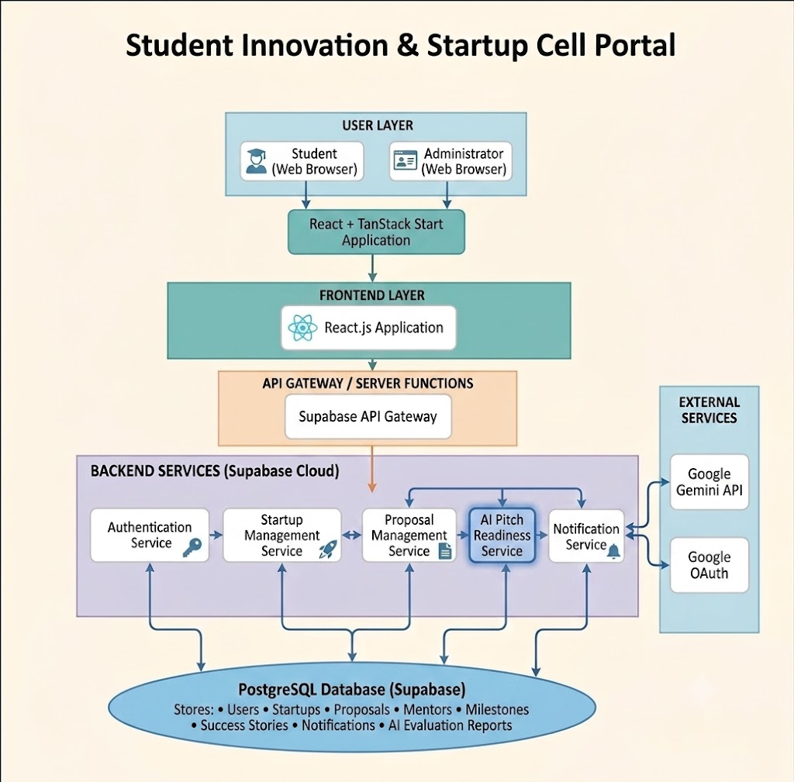

Description of Each Layer (Frontend, Backend, Database)

The Student Innovation & Startup Cell Portal follows a three-tier architecture, consisting of the Frontend Layer, Backend Layer, and Database Layer. This layered architecture separates the presentation, business logic, and data management components of the system, making the application more scalable, secure, and easier to maintain. Each layer performs specific responsibilities while communicating efficiently with the other layers through secure APIs and cloud services.

4.2.1 Frontend Layer
The Frontend Layer serves as the user interface of the Student Innovation & Startup Cell Portal. It is responsible for presenting information to users and providing an interactive and responsive experience. The frontend has been developed using React, TanStack Start, TypeScript, and Tailwind CSS, enabling a modern, component-based architecture with efficient routing and state management.
The frontend provides separate interfaces for students and administrators based on user roles. Students can register startups, submit proposals, access mentorship information, manage milestones, prepare MVPs, participate in Demo Day activities, and utilize the AI-Powered Pitch Readiness Checker. Administrators are provided with a dedicated dashboard to monitor startup registrations, review proposals, manage mentors, publish success stories, and oversee user accounts.
The frontend communicates with the backend through secure API requests and dynamically renders data received from the database. Client-side validation, responsive layouts, and intuitive navigation ensure a seamless user experience across desktops, laptops, tablets, and mobile devices.
Responsibilities of the Frontend Layer:
- Display user interfaces and dashboards.
- Collect user input through forms.
- Perform client-side validation.
- Manage application routing and navigation.
- Send API requests to backend services.
- Display data retrieved from the database.
- Provide a responsive and user-friendly interface.

4.2.2 Backend Layer
The Backend Layer contains the application's business logic and is responsible for processing requests received from the frontend. Instead of a traditional server, the Student Innovation & Startup Cell Portal utilizes Supabase Cloud as a Backend-as-a-Service (BaaS), which provides authentication, database access, API generation, and secure server-side operations.

The backend validates incoming requests, manages user authentication, enforces authorization policies, and coordinates interactions between the frontend, database, and external services. It also integrates the Google Gemini API to power the AI-Powered Pitch Readiness Checker, allowing startup ideas to be analyzed intelligently based on predefined evaluation parameters.

Supabase automatically generates secure REST APIs for database operations and implements Row-Level Security (RLS) policies to ensure that users can access only authorized data. The backend also manages notifications, proposal approvals, mentor assignments, and startup progress tracking.
Responsibilities of the Backend Layer:
- Authenticate and authorize users.
- Process business logic.

- Manage startup registrations and proposals.
- Handle mentor assignments and notifications.
- Communicate with the PostgreSQL database.
- Integrate Google Gemini API for AI analysis.
- Enforce security through Row-Level Security (RLS).
- Generate secure APIs for frontend communication.

4.2.3 Database Layer
The Database Layer is responsible for the persistent storage and management of all application data. The Student Innovation & Startup Cell Portal uses PostgreSQL, hosted and managed through Supabase, as its relational database management system.
The database stores comprehensive information related to users, startup registrations, proposals, mentors, milestones, MVP development, Demo Day participation, success stories, notifications, and AI-generated evaluation reports. Data is organized into normalized relational tables connected through primary and foreign keys, ensuring consistency and minimizing redundancy.

By leveraging PostgreSQL's advanced relational capabilities, the system efficiently performs data retrieval, updates, filtering, and reporting. Supabase additionally provides automatic backups, secure cloud hosting, and real-time synchronization capabilities, ensuring data availability and reliability.
The database is protected using Row-Level Security (RLS), ensuring that each user can access only the records permitted by their assigned role, thereby maintaining data confidentiality and integrity.
Responsibilities of the Database Layer:
- Store user and startup information.
- Maintain proposal and mentorship records.
- Store milestones and progress updates.
- Manage notifications and success stories.
- Store AI-generated pitch evaluation reports.
- Maintain relationships between database tables.
- Ensure data integrity and consistency.
- Support secure access through Row-Level Security (RLS).

Summary
The three-layer architecture adopted in the Student Innovation & Startup Cell Portal provides a clear separation of responsibilities between the user interface, application logic, and data storage. This modular design enhances scalability, simplifies maintenance, strengthens security, and enables future enhancements without affecting the overall system architecture. The integration of Supabase Cloud and Google Gemini API further enriches the application by providing reliable backend services and intelligent AI-assisted startup evaluation.

Deployment Architecture (Cloud, Local, CI/CD Pipelines)
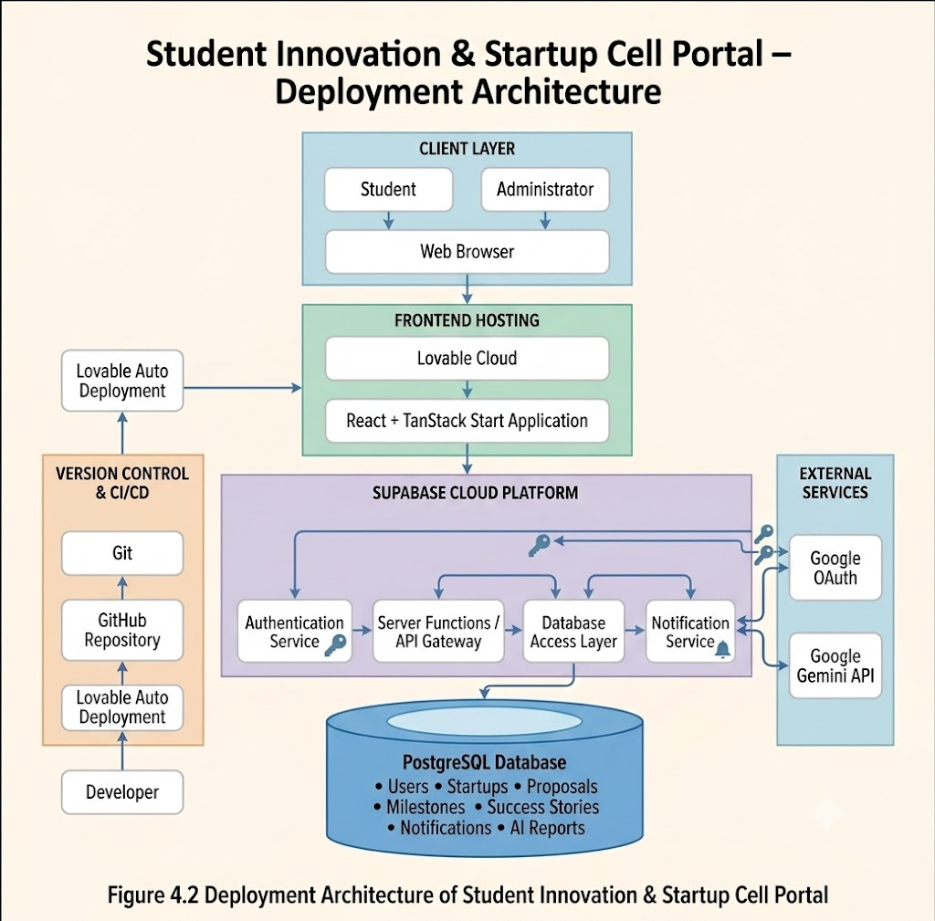

The Deployment architecture defines how the software application is hosted, executed, and made accessible to users after development. It explains the interaction between the client, frontend application, backend services, database, and external APIs within the deployment environment. The Student Innovation & Startup Cell Portal adopts a modern cloud-based deployment architecture that enables secure communication, high availability, scalability, and simplified maintenance.

The application is developed using a combination of local development tools and cloud-based services. During development, the project is executed locally using the Vite development server, while the production version is hosted through Lovable Cloud with backend services provided by Supabase. Version control and source code management are maintained using Git and GitHub, allowing collaborative development and automatic synchronization of project updates.

4.3.1 Local Development Environment
During the development phase, the Student Innovation & Startup Cell Portal is executed on the developer's local machine. Visual Studio Code serves as the primary Integrated Development Environment (IDE), while Node.js and npm manage project dependencies and development scripts.
The frontend application is built using React and TanStack Start, with Vite acting as the development server. Vite provides Hot Module Replacement (HMR), allowing developers to instantly view changes without restarting the application. The local application communicates directly with Supabase Cloud using environment variables stored in the .env configuration file.
The local development environment offers several advantages:
- Fast application startup using Vite.
- Real-time code updates through Hot Module Replacement.
- Easy debugging using browser developer tools.
- Secure API communication through environment variables.
- Direct connection to the cloud-hosted Supabase backend.

4.3.2 Cloud Deployment
The production version of the Student Innovation & Startup Cell Portal is deployed using Lovable Cloud, which hosts the frontend application and provides continuous synchronization with the connected GitHub repository. This cloud-based deployment allows users to access the application from any device with an internet connection without requiring software installation.

The backend services, including authentication, database operations, and API communication, are managed by Supabase Cloud. PostgreSQL serves as the cloud-hosted relational database, storing all application data such as user profiles, startup registrations, proposals, mentor details, notifications, and AI evaluation reports.

User authentication is handled securely through Google OAuth, enabling students and administrators to sign in using their Google accounts. The AI-Powered Pitch Readiness Checker communicates with the Google Gemini API, which analyzes startup information and generates intelligent evaluation reports.
The cloud deployment architecture offers several benefits, including:
- High system availability.
- Secure HTTPS communication.
- Automatic cloud backups.
- Centralized data management.
- Easy scalability for increasing users.
- Reduced infrastructure maintenance.
- Reliable authentication and authorization.

4.3.3 CI/CD Pipeline
The project follows a Continuous Integration and Continuous Deployment (CI/CD) workflow through GitHub and Lovable Cloud.

During development, source code changes are committed to the GitHub repository using Git version control. Whenever new updates are pushed to the repository, Lovable automatically synchronizes the changes and rebuilds the application. This automation minimizes manual deployment effort and ensures that the latest version of the application is always available.

The CI/CD workflow followed in this project consists of the following steps:
- Developers modify the application source code.
- Changes are committed using Git.
- Updated code is pushed to the GitHub repository.
- Lovable automatically detects repository changes.
- The application is rebuilt and deployed.
- The updated version becomes available to users without manual intervention.

This automated deployment process improves software quality, reduces deployment errors, and accelerates the development lifecycle.

4.3.4 Deployment Workflow
The deployment workflow of the Student Innovation & Startup Cell Portal follows the sequence illustrated below:
- The user accesses the application through a web browser.
- The frontend hosted on Lovable Cloud loads the user interface.
- User requests are securely transmitted to Supabase through HTTPS.
- Supabase authenticates users and processes application requests.
- Required data is retrieved from or stored in the PostgreSQL database.
- For AI-based pitch evaluation, startup information is securely sent to the Google Gemini API.
- Gemini processes the request and returns the evaluation results.
- The frontend displays the processed information to the user.
This workflow ensures secure communication, efficient request processing, and seamless integration between cloud services.

Advantages of the Deployment Architecture
The deployment architecture adopted for the Student Innovation & Startup Cell Portal provides several advantages:
- Cloud-based infrastructure eliminates the need for dedicated servers.
- Automatic deployment reduces manual effort and deployment errors.
- Secure authentication through Google OAuth enhances user security.
- PostgreSQL ensures reliable and scalable data storage.
- Google Gemini API enables intelligent AI-assisted startup evaluation.
- Git and GitHub facilitate efficient version control and collaborative development.
- The modular architecture allows future expansion without significant architectural modifications.

CHAPTER -5 DESIGN

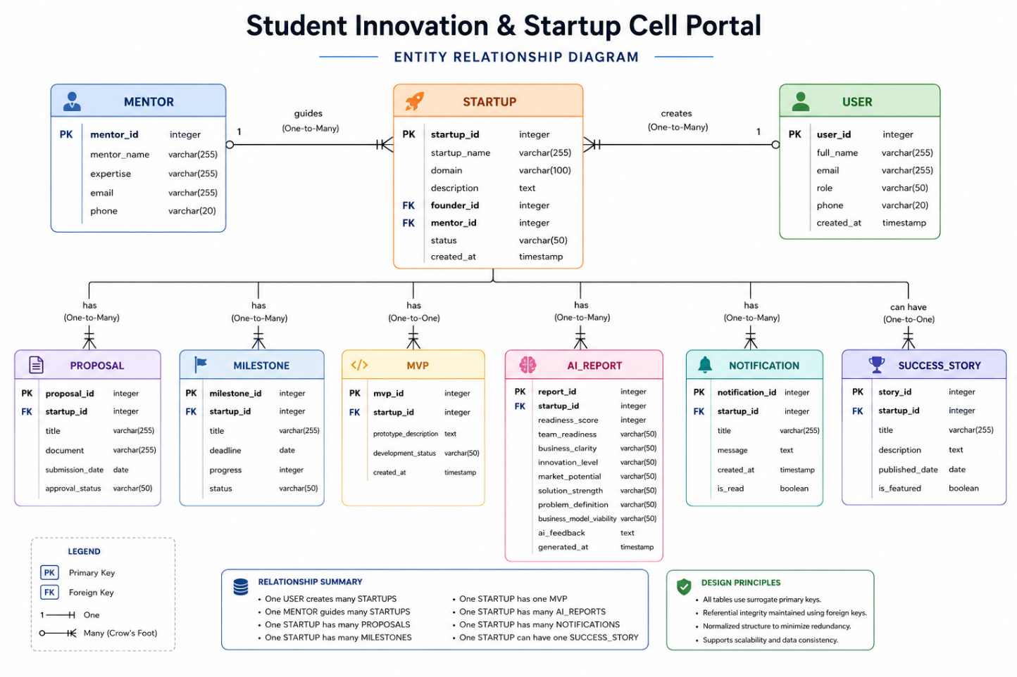

CHAPTER -6 IMPLEMENTATION

Section 6.1 – Module-Wise Implementation

The Student Innovation & Startup Cell Portal has been implemented by dividing the application into multiple independent modules. Each module performs a specific task while interacting seamlessly with other modules through the backend services.

6.1.1 User Authentication Module
The User Authentication Module is responsible for verifying user identity and controlling access to the application. The portal implements secure authentication using Supabase Authentication integrated with Google OAuth, allowing users to sign in using their Google accounts.
Once authenticated, Supabase creates a secure user session and stores authentication tokens that are used for subsequent API requests. Role-based authorization ensures that students and administrators can only access features relevant to their assigned roles.
Functionalities
- User registration
- Google Sign-In
- Session management
- Secure logout
- Role-based authorization
- Protected routes

6.1.2 Student Dashboard Module
The Student Dashboard serves as the primary workspace for registered students. It provides quick access to startup information, proposal status, assigned mentors, upcoming milestones, AI evaluation reports, MVP progress, and Demo Day activities.
The dashboard retrieves data dynamically from the backend and updates information in real time whenever the database changes.
Functionalities
- Startup overview
- Proposal tracking
- Mentor information
- Milestone progress
- Notifications
- AI evaluation reports
- Demo Day updates

6.1.3 Startup Management Module
The Startup Management Module enables students to create, edit, and manage startup information throughout the incubation process.
Students can provide startup details such as startup name, domain, business description, objectives, and current development stage. Administrators can review submitted startup profiles and monitor overall startup activities.
Functionalities
- Register startup
- Edit startup information
- View startup profile
- Track startup status
- Startup history

6.1.4 Proposal Management Module
This module allows students to submit startup proposals for review. Proposals include business ideas, objectives, implementation plans, and supporting documentation.
Administrators can review submitted proposals and update their approval status accordingly.
Functionalities
- Submit proposal
- Edit proposal
- View proposal history
- Proposal approval workflow
- Proposal status tracking

6.1.5 Mentor Management Module
The Mentor Module facilitates interaction between startups and assigned mentors.
Administrators assign mentors based on expertise, while students can view mentor details and monitor mentorship activities.
Functionalities
- Mentor assignment
- View mentor profile
- Track mentorship status
- Mentor recommendations

6.1.6 AI-Powered Pitch Readiness Checker
The AI-Powered Pitch Readiness Checker is the core innovation of the project. It evaluates startup ideas using the Google Gemini API and provides intelligent feedback regarding the startup's readiness for incubation or investment opportunities.
The module analyzes multiple business parameters and generates detailed evaluation reports.
Evaluation Parameters
- Team Readiness
- Business Clarity
- Innovation Level
- Market Potential
- Solution Strength
- Problem Definition
- Business Model Viability
Output Generated
- Overall Readiness Score
- Strengths
- Weaknesses
- Risk Analysis
- Improvement Suggestions
- Next Steps
This module enables students to refine their startup ideas before presenting them to mentors or investors.

6.1.7 Notification Module
The Notification Module keeps users informed about important activities occurring within the portal.
Notifications are generated automatically whenever significant events occur.
Examples include:
- Proposal approved
- Mentor assigned
- Startup registered
- Milestone reminder
- AI report generated
- Demo Day announcement

6.1.8 Admin Module
The Admin Module provides centralized control over the entire system.
Administrators can monitor users, startups, proposals, mentors, success stories, and application statistics through an interactive dashboard.
Functionalities
- Dashboard analytics
- User management
- Startup approval
- Proposal review
- Mentor management
- Success story management
- System monitoring

Section 6.2 – Front-End Logic (UI Rendering and State Management)

The frontend of the Student Innovation & Startup Cell Portal has been developed using React, TanStack Start, TypeScript, and Tailwind CSS to provide a fast, responsive, and interactive user experience. The frontend is responsible for rendering user interfaces, managing application state, validating user inputs, and communicating with backend services.
The application follows a component-based architecture where the user interface is divided into reusable components such as navigation bars, dashboards, cards, forms, buttons, modals, notifications, and AI evaluation panels. This modular approach improves code maintainability, scalability, and consistency throughout the application.
React's virtual DOM efficiently updates only the modified portions of the interface, reducing unnecessary re-rendering and improving application performance.

6.2.1 UI Rendering
The user interface is rendered dynamically based on user roles and data retrieved from the backend. Upon successful login, the application determines whether the authenticated user is a Student or an Administrator and displays the corresponding dashboard.
Student users can access modules such as Startup Registration, Proposal Submission, Mentor Information, MVP Development, Demo Day, AI Pitch Readiness Checker, and Notifications. Administrators are presented with a separate dashboard containing Startup Management, Proposal Review, Mentor Management, User Management, Success Stories, and Analytics.
The application utilizes reusable React components to ensure consistency in design and reduce code duplication. Components are rendered conditionally depending on authentication status, user role, and application state.
Major UI Components
- Landing Page
- Login & Authentication Page
- Student Dashboard
- Admin Dashboard
- Startup Registration Form
- Proposal Submission Form
- Mentor Management Page
- AI Pitch Readiness Checker
- Notifications Panel
- Success Stories Section
These components collectively provide an intuitive and user-friendly interface while maintaining a consistent visual design.

6.2.2 State Management
State management is responsible for controlling dynamic data displayed within the application. React's built-in state management mechanisms, combined with TanStack Start's routing capabilities, efficiently manage user sessions, application data, and page navigation.
Local component states are used to handle form inputs, loading indicators, modal visibility, and validation messages, while authentication status and user information are maintained globally throughout the application.
Whenever users submit startup information, proposals, or AI evaluation requests, the frontend updates the corresponding state variables and refreshes the user interface without requiring a complete page reload.
The application also displays loading animations while data is being retrieved from the backend, providing users with visual feedback during asynchronous operations.

6.2.3 Routing and Navigation
The portal uses TanStack Start's file-based routing system to manage navigation between different pages. Each route corresponds to a dedicated page within the application, enabling efficient code organization and simplified navigation.
Protected routes ensure that only authenticated users can access secure pages. Role-based routing further restricts administrative pages from being accessed by student users.
Major application routes include:
- Landing Page
- Authentication Page
- Student Dashboard
- Startup Module
- Proposal Module
- Mentor Module
- MVP Module
- Demo Day Module
- AI Pitch Readiness Checker
- Admin Dashboard
- Success Stories
Navigation between these pages is handled efficiently without full-page refreshes, resulting in a smooth single-page application experience.

6.2.4 Responsive User Interface
The frontend has been designed using Tailwind CSS, enabling a fully responsive interface that adapts to different screen sizes. Flexible layouts, responsive grids, and utility-based styling ensure consistent performance across desktops, laptops, tablets, and mobile devices.
The application automatically adjusts navigation menus, cards, forms, tables, and dashboards according to the screen resolution, providing users with an optimal viewing experience.
Responsive design improves accessibility and allows users to interact with the portal from multiple devices without compromising usability.

6.2.5 Form Handling and Validation
The portal contains several interactive forms for startup registration, proposal submission, profile updates, and AI pitch evaluation.
Before sending data to the backend, the frontend performs client-side validation to ensure that mandatory fields are completed correctly and invalid inputs are prevented. Validation messages are displayed instantly, improving user experience and reducing unnecessary API requests.
Examples of validated fields include:
- Email address
- Startup name
- Proposal title
- Business description
- Required AI evaluation inputs
Proper validation enhances data quality and minimizes errors during data submission.

6.2.6 User Experience Enhancements
Several features have been implemented to improve overall user experience, including:
- Interactive dashboards
- Dynamic cards and statistics
- Loading indicators during API requests
- Real-time notifications
- Responsive layouts
- Smooth page transitions
- Consistent color themes and typography
- Role-specific navigation menus
- Error handling with informative messages
These enhancements contribute to a modern and professional user interface suitable for a startup management platform.

Summary
The frontend implementation of the Student Innovation & Startup Cell Portal emphasizes modularity, responsiveness, and usability. By leveraging React, TanStack Start, TypeScript, and Tailwind CSS, the application delivers a seamless user experience while efficiently managing application state and rendering dynamic content. The component-based architecture, responsive layouts, and role-based navigation collectively ensure high performance, maintainability, and scalability of the frontend system.

6.3 API Integration

Application Programming Interfaces (APIs) act as the communication bridge between the frontend and backend components of the Student Innovation & Startup Cell Portal. API integration enables seamless data exchange, user authentication, database operations, and AI-powered startup evaluation. The project integrates Supabase APIs, Google OAuth, and the Google Gemini API to provide secure, reliable, and intelligent functionality.
The frontend communicates with backend services using secure HTTPS requests. Each request is authenticated using user session tokens generated by Supabase Authentication. The backend processes the request, performs the required database operations, and returns the appropriate response to the frontend for display.
This architecture ensures efficient communication between different system components while maintaining security, scalability, and data integrity.

6.3.1 Supabase API Integration
Supabase serves as the primary backend service for the application by providing REST APIs for database operations and authentication. It automatically generates secure APIs that allow the frontend to perform Create, Read, Update, and Delete (CRUD) operations without requiring manual API development.
The frontend communicates with Supabase to retrieve user information, startup details, proposal records, mentor assignments, notifications, milestones, and AI evaluation reports. Data is transmitted using secure HTTPS requests, and access is controlled through authentication tokens and Row-Level Security (RLS) policies.
Major Operations Performed
- User authentication
- Startup registration
- Proposal submission
- Mentor retrieval
- Startup progress tracking
- Notification management
- AI report storage
- User profile management
Supabase simplifies backend development by handling API generation, database communication, and security mechanisms automatically.

6.3.2 Google OAuth Integration
The application integrates Google OAuth to provide secure and convenient user authentication. Instead of creating separate usernames and passwords, users can log in using their existing Google accounts.
When a user selects "Continue with Google," the authentication request is redirected to Google's authentication service. After successful verification, Google returns the authenticated user information to Supabase, which creates a secure session and issues authentication tokens.
These tokens are subsequently used to authorize API requests throughout the user's session, ensuring that only authenticated users can access protected resources.
Benefits
- Secure authentication
- Faster login process
- Reduced password management
- Improved user experience
- Trusted authentication mechanism

6.3.3 Google Gemini API Integration
One of the key innovations of the Student Innovation & Startup Cell Portal is the integration of the Google Gemini API, which powers the AI-Powered Pitch Readiness Checker.
When students submit startup details for evaluation, the frontend sends the startup information to the backend, which securely forwards the request to the Google Gemini API. The AI model analyzes the provided startup information based on predefined business evaluation parameters and generates detailed feedback.
The generated report includes an overall readiness score, strengths, weaknesses, improvement suggestions, and recommendations for enhancing the startup pitch. The evaluation results are stored in the PostgreSQL database and displayed within the student's dashboard.
Parameters Evaluated
- Team Readiness
- Business Clarity
- Innovation Level
- Market Potential
- Solution Strength
- Problem Definition
- Business Model Viability
Output Generated
- Overall Pitch Readiness Score
- AI-generated feedback
- Improvement suggestions
- Business recommendations
- Next-step guidance
This AI integration significantly enhances the platform by providing students with intelligent insights before presenting their startup ideas to mentors or investors.

6.3.4 API Request Workflow
The API communication process within the application follows a structured workflow to ensure secure and efficient data exchange.
The sequence is as follows:
- The user performs an action through the frontend interface.
- The frontend sends an authenticated HTTPS request to the backend.
- Supabase verifies the user's authentication token.
- The backend processes the request according to business logic.
- Required data is retrieved from or stored in the PostgreSQL database.
- If AI evaluation is requested, startup details are forwarded to the Google Gemini API.
- The AI-generated response is returned to the backend.
- The backend stores the AI report in the database.
- The frontend receives the processed response and updates the user interface.
This workflow minimizes latency while ensuring secure communication between all system components.

6.3.5 API Security
To ensure secure communication, the application implements several security measures during API integration.
These include:
- HTTPS encryption for all API requests.
- Authentication using Supabase session tokens.
- Google OAuth for secure user login.
- Row-Level Security (RLS) to restrict unauthorized database access.
- Environment variables for securely storing API keys and configuration details.
- Input validation before sending requests to backend services.
These security mechanisms protect sensitive user information and maintain the integrity of the application.

Summary
The Student Innovation & Startup Cell Portal integrates multiple APIs to provide a secure and feature-rich user experience. Supabase APIs handle authentication and database communication, Google OAuth enables secure user login, and the Google Gemini API powers the AI-Powered Pitch Readiness Checker. Together, these integrations ensure efficient data exchange, intelligent startup evaluation, and reliable application performance while maintaining strong security standards.

6.4 Authentication and Authorisation

Authentication and authorization are essential components of the Student Innovation & Startup Cell Portal, ensuring that only verified users can access the application and perform actions according to their assigned roles. The project utilizes Supabase Authentication integrated with Google OAuth to provide a secure, reliable, and user-friendly login system.
The authentication mechanism verifies the identity of users, while the authorization system determines the level of access granted to each user based on predefined roles. This ensures that sensitive information and administrative functionalities remain protected from unauthorized access.

6.4.1 User Authentication
The portal implements secure authentication using Google OAuth through Supabase Authentication. Users are not required to create separate usernames and passwords. Instead, they can log in using their existing Google accounts, making the authentication process faster and more secure.
When a user clicks the "Continue with Google" button, the application redirects the user to Google's authentication service. After successful verification, Google returns the authenticated user information to Supabase. Supabase then creates a secure session and generates authentication tokens, which are used throughout the user's session to verify identity and authorize future requests.
This authentication flow minimizes security risks while providing a seamless user experience.
Authentication Process
- User selects Continue with Google.
- The application redirects the user to Google OAuth.
- Google verifies the user's credentials.
- Authentication details are securely sent to Supabase.
- Supabase creates a user session and generates access tokens.
- The user is redirected to the application dashboard.
- Protected routes become accessible based on the authenticated user's role.

6.4.2 Session Management
After successful authentication, Supabase manages the user's session automatically. Authentication tokens are securely stored and attached to every API request sent from the frontend to the backend.
The session remains active until the user explicitly logs out or the session expires. When the user signs out, all authentication tokens are removed, and access to protected resources is immediately revoked.
Automatic session management improves user convenience while maintaining application security.
Session Features
- Automatic session creation
- Secure token management
- Persistent login sessions
- Automatic session expiration
- Secure logout functionality

6.4.3 Authorization
Authorization determines what resources and functionalities an authenticated user can access. The Student Innovation & Startup Cell Portal follows a Role-Based Access Control (RBAC) approach.
Each authenticated user is assigned a role, such as Student or Administrator. Based on this role, the application dynamically displays the appropriate dashboard and restricts access to unauthorized pages.
For example:
- Students can register startups, submit proposals, view mentors, access AI Pitch Readiness Checker, track milestones, and participate in Demo Day activities.
- Administrators can review proposals, manage startups, assign mentors, publish success stories, monitor users, and oversee the entire incubation process.
This separation ensures that users only access the functionalities relevant to their responsibilities.

6.4.4 Protected Routes
The application protects sensitive pages by implementing protected routing using TanStack Start and Supabase Authentication.
Before rendering any secure page, the application verifies whether the user is authenticated. If the authentication check fails, the user is automatically redirected to the login page.
Protected routes include:
- Student Dashboard
- Admin Dashboard
- Startup Management
- Proposal Management
- Mentor Management
- MVP Module
- AI Pitch Readiness Checker
- Demo Day
- Notifications
This mechanism prevents unauthorized users from directly accessing secured application pages through URLs.

6.4.5 Database Security
Database-level security is implemented using Supabase Row-Level Security (RLS) policies. RLS ensures that users can only access records they are authorized to view or modify.
For example:
- Students can access only their own startup records and proposals.
- Administrators can access all startup information for monitoring and management.
- AI evaluation reports are available only to the respective startup owner and authorized administrators.
These security policies protect confidential startup information while maintaining data integrity across the system.

6.4.6 Security Measures
The application incorporates multiple security mechanisms to safeguard user information and application resources.
Security Features
- Google OAuth authentication
- Secure HTTPS communication
- Supabase Authentication
- Session token validation
- Protected application routes
- Role-Based Access Control (RBAC)
- Row-Level Security (RLS)
- Secure environment variables for API keys
- Input validation
- Secure logout and session termination
Together, these measures provide a robust security framework that protects user identities, startup data, and administrative operations.

Summary
The Student Innovation & Startup Cell Portal implements a comprehensive authentication and authorization system using Supabase Authentication and Google OAuth. Secure session management, role-based access control, protected routing, and database-level security ensure that users can safely access application resources according to their assigned roles. These mechanisms enhance both the security and reliability of the platform while providing a smooth and intuitive login experience.

CHAPTER 7- FEATURES

List of Main Features

The major features implemented in the Student Innovation & Startup Cell Portal are:
Student Features
- Student Authentication
- Dashboard
- Startup Registration & Management
- Proposal Submission
- Mentor Management
- MVP (Minimum Viable Product) Tracking
- Demo Day Module
- AI-Powered Pitch Readiness Checker
- Notifications
Administrator Features
- Admin Dashboard
- Startup Management
- Proposal Review & Approval
- Mentor Management
- Success Stories Management
- User Management
- System Monitoring

How Each Feature Works

7.2.1 User Authentication
User Perspective
Users access the application by signing in with their Google accounts. Once authenticated, they are automatically redirected to their respective dashboard based on their assigned role.
The authentication process is quick, secure, and eliminates the need for separate usernames and passwords.
Technical Description
Authentication is implemented using Supabase Authentication integrated with Google OAuth. After successful authentication, Supabase creates a secure session and stores authentication tokens, which are used to authorize subsequent API requests. Protected routes ensure that only authenticated users can access secure pages.

7.2.2 Student Dashboard
User Perspective
The Student Dashboard acts as the central workspace where students can monitor all startup activities from a single interface. It provides quick access to startup information, proposal status, mentor details, milestones, MVP progress, Demo Day participation, AI reports, and notifications.
Students can easily navigate between different modules without leaving the dashboard.
Technical Description
The dashboard dynamically retrieves information from the PostgreSQL database through Supabase APIs. React components render cards, statistics, notifications, and progress indicators in real time. State management ensures that updates are immediately reflected in the interface.

7.2.3 Startup Registration & Management
User Perspective
Students can register their startups by entering details such as startup name, business domain, objectives, and description. Registered startups can later be edited whenever necessary.
Students can also monitor the development status of their startup throughout the incubation process.
Technical Description
Startup information is stored in the PostgreSQL database using Supabase APIs. CRUD operations allow users to create, retrieve, update, and manage startup records securely. Row-Level Security policies ensure that students can only manage their own startup data.

7.2.4 Proposal Submission
User Perspective
Students can submit startup proposals for review through a dedicated proposal module. The submitted proposal can later be tracked to monitor approval status and feedback.
Administrators review proposals and update their approval status accordingly.
Technical Description
Proposal data is securely stored in the database through Supabase APIs. Validation is performed before submission to ensure that all required information has been provided. Proposal status is updated dynamically and reflected in the student dashboard.

7.2.5 Mentor Management
User Perspective
Students can view the mentors assigned to their startups along with their expertise and contact information. This enables effective communication and mentorship throughout the startup journey.
Administrators assign mentors based on startup domain and mentor specialization.
Technical Description
Mentor records are maintained within PostgreSQL and retrieved using Supabase APIs. Relationships between startup and mentor tables ensure accurate mentor allocation while maintaining data consistency.

7.2.6 MVP Module
User Perspective
The MVP (Minimum Viable Product) module enables students to monitor the development status of their startup prototype. Students can update progress as they build and validate their initial product.
This feature encourages structured product development before presenting the startup to mentors or investors.
Technical Description
MVP information is stored within dedicated database tables and updated through secure API requests. Progress information is displayed dynamically using React components.

7.2.7 Demo Day Module
User Perspective
Students can access Demo Day information, including upcoming presentations, participation status, schedules, and event details. This module helps startups prepare for institutional pitch presentations.
Technical Description
Demo Day data is retrieved from the backend database and rendered dynamically within the application. Administrators can update event schedules, participation records, and announcements.

7.2.8 AI-Powered Pitch Readiness Checker
User Perspective
The AI-Powered Pitch Readiness Checker allows students to evaluate the quality of their startup pitch before presenting it to mentors or investors. Students simply provide startup information, after which the system generates an intelligent evaluation report.
The report includes numerical scores and personalized recommendations for improving the startup presentation.
Technical Description
This module integrates the Google Gemini API with the frontend through Supabase backend services. Startup information is securely transmitted to the AI model, which evaluates the startup across multiple business parameters.
The generated report includes:
- Team Readiness
- Business Clarity
- Innovation Level
- Market Potential
- Solution Strength
- Problem Definition
- Business Model Viability
- Overall Readiness Score
- AI Feedback
- Recommendations
The results are stored in PostgreSQL and displayed within the student's dashboard.

7.2.9 Notification System
User Perspective
Students receive notifications whenever important events occur, such as proposal approval, mentor assignment, milestone reminders, AI report generation, or Demo Day announcements.
These notifications keep users informed about startup activities without requiring manual tracking.
Technical Description
Notifications are generated automatically by backend services and stored in PostgreSQL. The frontend periodically retrieves notification records and displays them within the dashboard.

7.2.10 Admin Dashboard
User Perspective
The Administrator Dashboard provides complete control over the portal. Administrators can monitor startup registrations, proposal submissions, mentor assignments, user accounts, and success stories from a centralized interface.
Interactive statistics and summaries assist administrators in monitoring overall system performance.
Technical Description
The dashboard aggregates information from multiple database tables using Supabase queries. Dynamic charts, cards, and summary panels are rendered using React components.

7.2.11 Success Stories Management
User Perspective
Administrators can publish successful startup journeys to motivate aspiring entrepreneurs. Students can browse these stories to gain inspiration and learn from previous achievements.
Technical Description
Success stories are stored within PostgreSQL and displayed through reusable frontend components. Administrators can create, update, and manage published stories through the admin panel.

7.2.12 User Management
User Perspective
Administrators can monitor registered users and manage system access based on assigned roles. This ensures proper administration of the portal.
Technical Description
User information is managed through Supabase Authentication and PostgreSQL. Role-Based Access Control (RBAC) determines permissions and restricts unauthorized operations.

Summary
The Student Innovation & Startup Cell Portal combines secure authentication, startup lifecycle management, mentorship, proposal handling, AI-assisted evaluation, and administrative control into a unified platform. The integration of cloud services, modern web technologies, and artificial intelligence enhances usability, streamlines startup incubation activities, and promotes innovation among students.

✅ Chapter 7 Complete
This chapter should occupy a

CHAPTER -8 TESTING

Postman Testing (Frontend/Backend)

Postman is a widely used API testing tool that allows developers to test RESTful APIs independently of the frontend application. Although Supabase automatically generates secure APIs, Postman was used to verify API responses, validate request parameters, and ensure proper communication between the frontend and backend services.
API testing confirmed that all requests returned the expected responses and that authentication mechanisms functioned correctly.
APIs Tested
- User Authentication API
- Startup Registration API
- Proposal Submission API
- Mentor Management API
- User Profile API
- Notification API
- AI Report Storage API
- Database CRUD Operations
Test Parameters
- Request URL validation
- HTTP request methods (GET, POST, PUT, DELETE)
- Response status codes
- Authentication token verification
- Response data validation
- Error handling
Outcome
All APIs successfully processed valid requests and returned appropriate responses. Invalid requests generated meaningful error messages without affecting system stability.

Integration Testing

Integration testing was conducted to ensure that all modules of the Student Innovation & Startup Cell Portal communicate effectively and function correctly as a complete system. Unlike unit testing, which verifies individual modules independently, integration testing focuses on validating the interaction between different software components, APIs, and database services.
The application integrates several technologies, including React, TanStack Start, Supabase Authentication, PostgreSQL, Google OAuth, and Google Gemini API. Each of these components was tested together to verify seamless communication, correct data flow, and consistent functionality throughout the application.
During testing, different user scenarios were executed to verify that data entered through the frontend was correctly transmitted to the backend, securely stored in the PostgreSQL database, and retrieved whenever required. The integration between authentication services and protected routes was also tested to ensure that unauthorized users could not access restricted resources.

Special attention was given to the AI-Powered Pitch Readiness Checker, as it communicates with an external AI service. Test cases verified that startup information submitted by students was successfully sent to the Google Gemini API and that the generated evaluation reports were correctly stored and displayed within the application.
Integration Scenarios Tested
- Google OAuth authentication integrated with Supabase Authentication.
- Student login leading to successful dashboard access.
- Startup registration synchronized with the PostgreSQL database.
- Proposal submission and retrieval from the backend database.
- Mentor assignment reflected on the student dashboard.
- AI Pitch Readiness Checker communicating with Google Gemini API.
- Notifications automatically displayed after database updates.
- Admin actions immediately reflected on the student interface.
- Secure communication between frontend and backend services.
- Role-based navigation after successful authentication.

Results
All integrated modules communicated successfully without major issues. Database operations were executed correctly, authentication tokens were validated properly, and AI-generated reports were successfully returned and displayed. The integration testing confirmed that the overall application workflow operated smoothly and met the intended functional requirements.

Tools Used for Testing

The A variety of software development and testing tools were used throughout the implementation and validation of the Student Innovation & Startup Cell Portal. These tools assisted in debugging, API verification, frontend rendering, backend monitoring, database management, version control, and application deployment.
The combined use of these tools improved development efficiency, accelerated debugging, and ensured that the application met the expected quality standards before deployment.

Visual Studio Code
Visual Studio Code served as the primary Integrated Development Environment (IDE) for developing and testing the frontend and backend components. Its built-in debugging capabilities, extensions, syntax highlighting, and integrated terminal simplified the software development process.

Google Chrome Developer Tools
Chrome Developer Tools were extensively used for frontend debugging. The Network tab was utilized to inspect API requests and responses, while the Console helped identify JavaScript errors. The Elements panel was used to verify responsive layouts and CSS styling.

Postman
Postman was used to verify backend API functionality independently from the frontend. Various HTTP requests such as GET, POST, PUT, and DELETE were executed to ensure proper request handling and response generation.

Supabase Dashboard
The Supabase Dashboard was used to monitor database tables, authentication records, Row-Level Security (RLS) policies, API logs, and user sessions. It also assisted in validating database updates and backend operations during testing.

npm
The Node Package Manager (npm) was used to install project dependencies and verify successful application builds. Dependency conflicts and package updates were resolved using npm throughout development.

Git and GitHub
Git was used for version control, while GitHub maintained the project's source code repository. Code changes were tracked efficiently, allowing multiple versions of the project to be managed throughout development.

Google Gemini API
The Google Gemini API was tested to ensure accurate AI-generated pitch evaluations. Startup information submitted through the application was analyzed by the AI model, and the generated feedback was validated for correctness and consistency.

Summary of Testing Tools
Tool | Purpose
Visual Studio Code | Application development, debugging, and code editing
Google Chrome Developer Tools | Frontend debugging, performance analysis, and network monitoring
Postman | API request and response testing
Supabase Dashboard | Database management, authentication, and backend monitoring
npm | Dependency management and build verification
Git | Version control
GitHub | Source code repository and project collaboration
Google Gemini API | AI response generation and validation

Overall Testing Outcome
The combination of these testing tools enabled comprehensive verification of the Student Innovation & Startup Cell Portal. Functional testing, integration testing, API validation, database verification, authentication testing, and AI response evaluation collectively ensured that the application operates reliably, securely, and efficiently under normal usage conditions.

Test Cases and Results

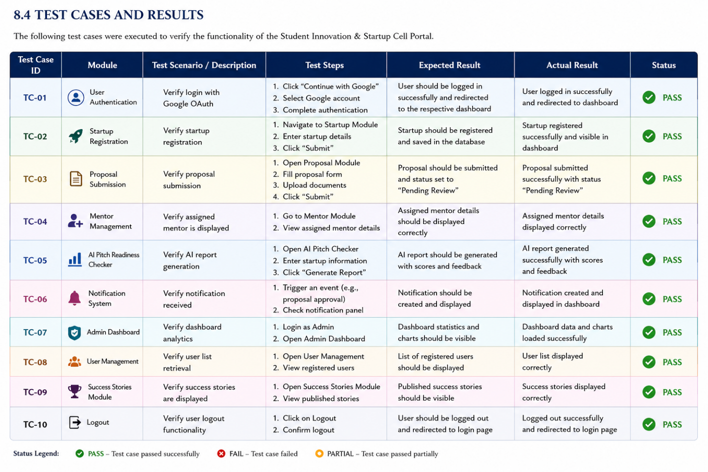

CHAPTER -9 DEPLOYMENT

Steps to Deploy

The deployment process of the Student Innovation & Startup Cell Portal follows a structured workflow to ensure that all components are configured correctly before making the application available to users.
Initially, the project source code is maintained in a GitHub repository, which serves as the central version control system. Developers make changes locally using Visual Studio Code and synchronize updates through Git.
After implementation, project dependencies are installed using Node Package Manager (npm). The application is then configured with the required environment variables, including Supabase project credentials and API keys for Google Gemini AI.
The frontend application is built and deployed using Lovable Cloud, which automatically generates a production-ready web application. Supabase manages backend services, including database operations, authentication, storage, and security policies.
Once deployment is complete, the application becomes accessible through a public web URL where users can securely sign in and access the platform.
Deployment Steps
- Develop the application using React, TanStack Start, and TypeScript.
- Maintain project source code using Git and GitHub.
- Install project dependencies using npm.
- Configure environment variables (.env).
- Connect the application with Supabase backend services.
- Configure Google OAuth authentication.
- Integrate the Google Gemini API for AI functionality.
- Build the production version of the application.
- Deploy the frontend using Lovable Cloud.
- Verify authentication, database connectivity, and application functionality.
Following these steps ensures a smooth deployment process while minimizing configuration errors.

Environment Configuration

Environment configuration is an essential aspect of deploying the Student Innovation & Startup Cell Portal, as it ensures secure communication between the frontend application, backend services, authentication system, database, and artificial intelligence platform. Proper configuration allows the application to function consistently across different environments such as local development, testing, and production without requiring changes to the application source code.

During development, the project uses a dedicated .env file to store important configuration parameters and credentials. These include the Supabase project URL, the Supabase publishable authentication key, and the Google Gemini API key used by the AI-Powered Pitch Readiness Checker. Storing these values in environment variables instead of directly embedding them into the application source code significantly improves security and prevents sensitive information from being exposed in public repositories or shared among unauthorized users.

The frontend application accesses these variables during runtime to establish secure communication with the backend services. The Supabase URL identifies the cloud database and authentication service that the application should connect to, while the publishable key allows secure interaction with Supabase APIs. Similarly, the Google Gemini API key authorizes requests made by the application to generate AI-based startup evaluations and personalized pitch improvement suggestions.

During local development, developers manually configure these environment variables before running the application using Node.js and npm. Once configured, the application can securely authenticate users, retrieve startup records, store proposals, manage notifications, and generate AI reports exactly as it would in the production environment. This consistency enables developers to thoroughly test all functionalities before deployment.

For production deployment, environment variables are managed securely through the hosting platform rather than being stored directly in project files. Cloud platforms such as Lovable Cloud and Supabase provide secure mechanisms for storing configuration values, ensuring that confidential credentials remain encrypted and inaccessible to end users. This approach minimizes security risks and simplifies future maintenance, as configuration values can be updated independently without modifying the application's codebase.

Another important advantage of environment configuration is flexibility. If the application needs to connect to a different backend service, migrate to another database, or update API credentials, only the environment variables need to be modified. The application itself remains unchanged, reducing development effort and minimizing the possibility of introducing errors. This separation of configuration from application logic follows modern software engineering practices and supports scalable application development.

Overall, the environment configuration strategy adopted in this project enhances security, simplifies deployment, supports multiple development environments, and improves maintainability. It ensures that the Student Innovation & Startup Cell Portal remains reliable, secure, and adaptable as new features and services are integrated in the future.

Hosting of Frontend and Backend

The Student Innovation & Startup Cell Portal adopts a cloud-based deployment architecture in which different components of the application are hosted on specialized platforms based on their functionality. This distributed hosting approach improves system performance, scalability, security, and maintainability while allowing each component to operate independently. By separating the frontend, backend, database, authentication system, and AI services, the application can efficiently handle user requests while maintaining a high level of reliability.

The frontend of the application is hosted using Lovable Cloud, which provides an automated deployment environment specifically designed for modern React-based applications. After the source code is synchronized with the connected GitHub repository, Lovable Cloud automatically builds the project, installs the required dependencies, generates an optimized production build, and deploys the application to a secure web server. This automated deployment process eliminates the need for manual configuration and ensures that every code update is reflected in the deployed application with minimal effort.

Hosting the frontend on a cloud platform allows students, mentors, and administrators to access the portal from any device equipped with a modern web browser. Since the application is delivered over HTTPS, all communication between users and the system remains encrypted, improving both privacy and security. The responsive design implemented using React and Tailwind CSS further ensures that the portal functions efficiently across desktops, laptops, tablets, and mobile devices.

The backend infrastructure is powered by Supabase, which provides a Backend-as-a-Service (BaaS) solution. Supabase manages the PostgreSQL database, user authentication, REST APIs, file storage, and Row-Level Security (RLS) policies required by the application. Instead of developing and maintaining a dedicated backend server, the project leverages Supabase's managed services to simplify development while maintaining enterprise-grade security and reliability.

The PostgreSQL database hosted by Supabase stores all application-related information, including user accounts, startup details, proposals, mentor assignments, milestones, MVP progress, notifications, success stories, and AI-generated evaluation reports. The database is protected using secure authentication mechanisms, encrypted communication channels, automated backup systems, and access control policies. These features ensure data integrity while safeguarding sensitive startup information from unauthorized access.

User authentication is also managed entirely through Supabase Authentication, which integrates with Google OAuth to provide secure login functionality. Users can sign in using their Google accounts without creating separate usernames and passwords. After successful authentication, Supabase generates secure session tokens that authorize future API requests and maintain user sessions throughout the application. This cloud-based authentication mechanism significantly improves both security and user convenience.

One of the most innovative components of the project is the AI-Powered Pitch Readiness Checker, which integrates with the Google Gemini API. Since Gemini is a cloud-hosted artificial intelligence service, all AI processing occurs externally without increasing the computational requirements of the application server. Whenever students request an evaluation of their startup idea, the application securely sends the startup information to the Gemini API and receives a detailed assessment containing readiness scores, business feedback, and personalized improvement suggestions. This cloud-based AI integration allows the portal to deliver advanced intelligent features without requiring expensive local computing resources.

The complete project source code is maintained using Git and GitHub, which serve as the version control platform throughout the software development lifecycle. Git tracks every modification made to the project, while GitHub stores the central repository and facilitates collaboration, backup, and version management. The integration between GitHub and Lovable Cloud enables automatic synchronization of source code changes, allowing the deployed application to remain up to date whenever new features or bug fixes are introduced.

For development and testing purposes, the application can also be executed locally using Visual Studio Code, Node.js, npm, and the configured environment variables. Developers can install project dependencies, run the development server, debug application logic, verify API responses, and test newly implemented features before deploying them to the production environment. This local development workflow ensures that potential issues are identified and resolved early, improving overall software quality.

The deployment architecture adopted for the Student Innovation & Startup Cell Portal provides numerous advantages, including automatic deployment, centralized data management, secure authentication, cloud scalability, high system availability, simplified maintenance, and continuous integration with version control systems. These characteristics ensure that the platform can efficiently support increasing numbers of users while remaining flexible enough to accommodate future enhancements such as investor networking, mobile application support, advanced analytics, and additional AI-powered services.

Overall, the deployment strategy combines modern cloud technologies with secure backend infrastructure to deliver a reliable, scalable, and high-performance startup management platform. By utilizing Lovable Cloud, Supabase, Google Gemini API, GitHub, and modern deployment practices, the Student Innovation & Startup Cell Portal is well-equipped to meet the needs of educational institutions while supporting future technological growth and expansion.

CHAPTER -10 CHALLENGES & LIMITATIONS

Issues Faced During Development

Developing a full-stack startup management platform required integrating various frontend, backend, authentication, database, and artificial intelligence services. Throughout the project, several challenges arose that required careful analysis and problem-solving.

One of the primary challenges involved configuring secure user authentication using Google OAuth with Supabase Authentication. Since the application was tested in both local and cloud environments, redirect URI configurations occasionally caused authentication failures. Proper OAuth configuration and environment setup were necessary to establish secure login functionality.

Another significant challenge involved connecting the frontend with the Supabase backend while maintaining secure database communication. Environment variables needed to be configured correctly for different development environments, and incorrect configuration occasionally resulted in failed API requests or database connection errors.

Integrating the Google Gemini API for the AI-Powered Pitch Readiness Checker presented additional complexity. Startup information had to be securely transmitted to the AI service, and responses needed to be processed and displayed efficiently. Prompt design also required refinement to ensure meaningful and consistent AI-generated evaluations.

Managing application state across multiple interconnected modules such as Dashboard, Startup Management, Proposal Submission, Mentor Assignment, MVP Tracking, and AI Reports was another challenge. Ensuring real-time updates without affecting application performance required careful implementation using React's state management features.

Version control and deployment also introduced challenges. Synchronizing project updates through GitHub while maintaining compatibility with the deployment platform required proper branch management and dependency handling. Local development sometimes differed from the cloud environment due to configuration differences, requiring additional debugging before deployment.

Furthermore, designing a responsive and user-friendly interface for both students and administrators required several iterations. Balancing functionality with simplicity was essential to ensure that users with varying technical backgrounds could easily navigate the portal.

Solutions Applied

Each challenge encountered during development was addressed using appropriate technical solutions and best software engineering practices.
To resolve authentication issues, Supabase Authentication was integrated with Google OAuth, and all required redirect URIs and environment configurations were properly configured. This ensured secure login functionality across both local development and production environments.

Database connectivity issues were addressed by securely managing environment variables and validating API configurations before deployment. Sensitive credentials such as Supabase URLs and API keys were stored in environment files rather than hardcoded into the application, improving both security and maintainability.

The AI-Powered Pitch Readiness Checker was enhanced through prompt optimization and structured communication with the Google Gemini API. Startup information was validated before submission, and AI responses were processed into meaningful readiness scores and detailed feedback reports.

To improve frontend performance, React component architecture was modularized, allowing each feature to function independently while maintaining efficient communication with backend services. Reusable UI components reduced code duplication and simplified future maintenance.

Version control challenges were managed using Git and GitHub, allowing changes to be tracked systematically throughout the development lifecycle. Frequent commits and repository synchronization helped prevent code conflicts and ensured project stability.

Application responsiveness was improved through Tailwind CSS and responsive design principles. Multiple screen sizes were tested to ensure compatibility across desktops, laptops, tablets, and mobile devices.
Comprehensive testing was also performed throughout development to identify issues early. Functional testing, API testing, and integration testing helped ensure that each module operated correctly before deployment.

Current Limitations or Known Bugs

Although the Student Innovation & Startup Cell Portal successfully achieves its primary objectives, certain limitations remain due to project constraints and available development time.
Currently, the platform primarily supports startup management within a single educational institution. Multi-institution support has not yet been implemented.

The AI-Powered Pitch Readiness Checker provides intelligent recommendations based on the information submitted by students. However, the quality of the generated evaluation depends on the completeness and accuracy of the input provided by the user. The AI does not replace professional mentorship but serves as an intelligent guidance tool.
The application currently supports Google OAuth as the primary authentication mechanism. Additional authentication methods such as Microsoft, Apple, or institutional Single Sign-On (SSO) are not yet available.
Real-time messaging between students and mentors has not been implemented. Communication currently occurs outside the application through conventional channels such as email or messaging applications.

The Demo Day module provides event information and participation management but does not currently support live event streaming, virtual presentations, or online judging.
The system is optimized for modern web browsers and requires a stable internet connection to access cloud services such as Supabase and Google Gemini API. Offline functionality is not currently supported.

Although the database architecture is scalable, extremely large numbers of concurrent users may require additional backend optimization and infrastructure scaling for enterprise-level deployment.
Despite these limitations, the current implementation successfully fulfills the project's objectives by providing a secure, intelligent, and user-friendly startup incubation platform for educational institutions.

Conclusion
The challenges encountered during the development of the Student Innovation & Startup Cell Portal contributed significantly to the overall learning experience. By overcoming issues related to authentication, cloud deployment, API integration, artificial intelligence, database management, and responsive interface design, the project achieved a stable and fully functional implementation. While certain limitations remain, they provide valuable opportunities for future enhancements and demonstrate the scalability of the proposed system.

CHAPTER -11 FUTURE ENHANCEMENTS

Planned Features

The following features are proposed for future versions of the Student Innovation & Startup Cell Portal to further enhance its functionality and improve the overall user experience.

AI-Based Startup Recommendation System
The current AI module evaluates startup ideas and provides pitch readiness feedback. In future versions, artificial intelligence can be extended to recommend suitable business models, market strategies, funding opportunities, and technology stacks based on the startup's domain and objectives.
The recommendation engine could analyze startup descriptions and automatically suggest similar successful startups, potential risks, competitor analysis, and possible growth opportunities. This would provide students with more personalized guidance throughout their entrepreneurial journey.

Real-Time Mentor–Student Communication
Currently, communication between mentors and students takes place outside the application. A built-in messaging system can be introduced to facilitate direct communication within the portal.
This feature would allow students to ask questions, share project updates, receive mentor feedback, schedule meetings, and maintain complete communication history. Real-time messaging would significantly improve collaboration and strengthen mentor-student relationships.

Investor Networking Portal
A dedicated investor portal can be introduced where verified investors can browse promising student startups and connect directly with founders.
Students would be able to showcase their startup profiles, business proposals, pitch decks, MVP demonstrations, and AI readiness reports. Investors could review startup progress, evaluate business potential, and express interest in funding innovative ideas.
This enhancement would transform the platform from an incubation portal into a comprehensive startup ecosystem.

Advanced Analytics Dashboard
Future versions can include advanced analytics dashboards that provide detailed insights into startup performance and institutional innovation activities.
The analytics dashboard may display:
- Startup growth trends
- Proposal approval statistics
- Mentor engagement metrics
- Student participation reports
- AI evaluation trends
- Incubation success rates
- Department-wise startup statistics
Interactive charts and graphical reports would assist administrators in making informed decisions regarding startup incubation programs.

Mobile Application
Developing an Android and iOS mobile application would significantly improve accessibility for students and mentors.
A mobile application would enable users to:
- Receive instant notifications
- Submit proposals
- Track startup progress
- Access mentor guidance
- View AI reports
- Participate in Demo Day activities
Mobile support would increase user engagement by allowing startup management anytime and anywhere.

Document Management System
Future enhancements can include a secure document management system where students can upload, organize, and manage important startup-related documents.
Examples include:
- Business plans
- Financial reports
- Legal documents
- Pitch decks
- Prototype documentation
- Intellectual property records
Cloud storage integration would ensure secure access and simplify document sharing with mentors and administrators.

Online Demo Day Platform
The existing Demo Day module can be expanded into a complete virtual event management platform.
Future functionality may include:
- Live presentations
- Video conferencing
- Online judging
- Audience voting
- Digital certificates
- Event recordings
This enhancement would enable institutions to organize virtual startup competitions without geographical limitations.

Automated Email and Notification System
Future versions may integrate automated email services to notify users regarding proposal approvals, mentor assignments, milestone deadlines, Demo Day schedules, and AI evaluation completion.
Email reminders would improve communication while reducing manual administrative effort.

Possible Integrations or Optimisations

To further improve scalability and functionality, several third-party integrations and technical optimizations can be implemented in future releases.
One possible enhancement is the integration of payment gateways to facilitate startup registration fees, incubation program payments, or premium mentorship services. Secure payment processing would simplify financial transactions within the platform.

The platform can also be integrated with LinkedIn to automatically import professional profiles of mentors and entrepreneurs, reducing manual profile creation and improving networking opportunities.
Cloud storage services such as Google Drive, OneDrive, or AWS S3 may be integrated to provide secure storage for startup documents, business plans, prototype files, and multimedia resources.

Future optimization can also focus on improving application performance through caching mechanisms, database indexing, lazy loading of components, and optimized API communication. These improvements would reduce response time and improve scalability as the number of users increases.

Another promising enhancement involves implementing predictive analytics using machine learning algorithms. By analyzing historical startup data, the system could predict startup success probability, identify high-potential ideas, and recommend suitable incubation strategies.

The portal may also support multi-institution deployment, allowing multiple colleges and universities to use the same platform with institution-specific dashboards, branding, and administrative controls. This would significantly expand the impact of the project and make it suitable for statewide or national startup incubation initiatives.

In addition, integrating real-time collaboration tools, calendar scheduling, video conferencing platforms, and cloud-based productivity applications would further improve communication between students, mentors, and administrators.

Finally, future versions can adopt containerized deployment technologies such as Docker and automated CI/CD pipelines using GitHub Actions to streamline software updates, improve deployment efficiency, and simplify maintenance in production environments.

Conclusion
The Student Innovation & Startup Cell Portal has been designed with scalability and extensibility in mind, allowing new features and technologies to be integrated with minimal architectural changes. The proposed enhancements—including AI-driven recommendations, investor networking, mobile application support, advanced analytics, real-time communication, and multi-institution deployment—have the potential to transform the platform into a comprehensive digital ecosystem for innovation and entrepreneurship. These future developments will not only improve user experience but also strengthen the platform's ability to support startup incubation at larger institutional and organizational levels.

CHAPTER -12 CONCLUSION

  - Summary of the Project

The rapid growth of entrepreneurship and innovation has significantly transformed the educational landscape by encouraging students to develop creative solutions to real-world problems through startup initiatives. Educational institutions are increasingly establishing dedicated Startup Cells and Innovation Centers to foster entrepreneurial thinking, provide mentorship, facilitate industry collaboration, and support students throughout their startup journey. These Startup Cells act as a bridge between innovative ideas and successful business ventures by providing incubation support, technical guidance, funding opportunities, networking events, and access to experienced mentors. However, the management of startup-related activities using conventional methods such as spreadsheets, paper-based records, email communication, and isolated software solutions often results in inefficient workflows, poor communication, lack of centralized information, duplication of records, and difficulties in tracking the progress of student startups. These challenges not only increase administrative workload but also reduce the overall efficiency of startup management within educational institutions.

The Startup Cell Management System is a comprehensive web-based platform designed to digitalize and automate the complete startup management process within an institution. The application provides a centralized ecosystem where students, mentors, startup coordinators, and administrators can collaborate effectively throughout the entrepreneurial lifecycle. Students can register their startups, submit innovative business proposals, communicate with assigned mentors, manage project milestones, prepare investor presentations, participate in institutional startup events, and continuously monitor the development of their entrepreneurial ventures. The platform eliminates the need for fragmented communication and manual record keeping by integrating all startup-related activities into a single, user-friendly system. At the same time, administrators are provided with an advanced management dashboard that enables them to efficiently monitor startup registrations, review proposals, assign mentors, publish announcements, organize events, analyze startup performance, and oversee the institution's overall entrepreneurial ecosystem through an intuitive interface.

One of the most innovative features of the proposed system is the AI-Powered Startup Evaluation and Pitch Readiness Module, which leverages Google's Gemini API to intelligently analyze startup ideas and assess their readiness for incubation programs, startup competitions, and investor presentations. Unlike traditional evaluation methods that depend entirely on manual review, the AI module provides instant, consistent, and data-driven feedback to aspiring entrepreneurs. The system evaluates multiple critical business parameters including Problem Identification, Innovation and Creativity, Market Opportunity, Business Model Strength, Team Capability, Product Readiness, Competitive Advantage, Financial Sustainability, and Overall Growth Potential. Based on these evaluations, the platform generates a comprehensive readiness score accompanied by detailed strengths, weaknesses, improvement suggestions, and personalized recommendations. This intelligent decision-support system enables students to identify potential gaps in their business strategies at an early stage, refine their startup concepts, improve their investor pitches, and increase their chances of securing mentorship, incubation opportunities, and funding support.

The application has been developed using modern web technologies to ensure high performance, scalability, and maintainability. The frontend is built using React with TanStack Start and TypeScript, enabling the development of a responsive, modular, and highly interactive user interface. Tailwind CSS has been utilized to create a modern, responsive, and visually appealing design that provides an optimal user experience across desktop, tablet, and mobile devices. Backend services including authentication, database management, and real-time data synchronization are powered by Supabase, while PostgreSQL serves as the primary relational database for securely storing user information, startup details, proposal records, mentor assignments, and system data. Secure user authentication is implemented through Google OAuth, allowing users to log in conveniently while maintaining high security standards. The integration of the Google Gemini API enhances the platform with Artificial Intelligence capabilities, enabling automated startup analysis and intelligent recommendation generation.

The portal provides dedicated interfaces for different categories of users, ensuring role-based functionality and efficient workflow management. Students are provided with a personalized dashboard where they can register startups, submit proposals, monitor startup progress, manage business documents, connect with mentors, prepare investor presentations, participate in Demo Day events, and receive AI-generated startup evaluations. Mentors have access to dashboards that allow them to review assigned startups, monitor entrepreneurial progress, provide technical and business guidance, evaluate student submissions, and communicate with startup teams effectively.
Administrators are equipped with a comprehensive management console that enables them to oversee all institutional startup activities, manage user accounts, verify startup registrations, review business proposals, assign mentors, publish announcements, organize entrepreneurship events, generate analytical reports, and monitor overall startup performance through real-time statistics and visual dashboards. This structured role-based architecture ensures secure access control while providing each user with features specifically designed for their responsibilities.

The primary objective of the Startup Cell Management System is to establish a fully digital ecosystem that promotes entrepreneurship, innovation, collaboration, and efficient startup management within educational institutions. The platform seeks to eliminate the limitations associated with manual administrative processes by providing a centralized, transparent, and automated solution for managing startup activities. Through the integration of Artificial Intelligence, secure authentication, cloud-based database management, and responsive web technologies, the system enhances both administrative efficiency and the entrepreneurial experience of students. The AI-driven evaluation mechanism further assists users in improving the quality of their startup ideas by providing actionable insights, thereby supporting better decision-making throughout the startup lifecycle.

Beyond administrative automation, the system contributes significantly to creating a culture of innovation by encouraging collaboration among students, mentors, faculty members, industry experts, and institutional administrators. The centralized platform improves communication, simplifies mentorship management, enhances transparency in proposal evaluation, and enables continuous monitoring of startup progress through well-organized dashboards and analytical reports. By providing a structured environment for startup development, the system empowers aspiring entrepreneurs to transform innovative ideas into viable business ventures while enabling institutions to efficiently manage entrepreneurship programs and measure their overall impact.

In conclusion, the Startup Cell Management System serves as an intelligent, scalable, and comprehensive solution for managing the complete entrepreneurial ecosystem within educational institutions. By integrating modern web technologies, cloud-based infrastructure, Artificial Intelligence, and user-centric design principles, the platform significantly improves the efficiency of startup management while reducing administrative overhead. The system not only simplifies the processes of startup registration, proposal management, mentorship coordination, and event organization but also equips students with intelligent evaluation tools that strengthen their entrepreneurial capabilities. Ultimately, the proposed system fosters transparency, collaboration, innovation, and continuous learning, creating a sustainable digital ecosystem that prepares students to become successful entrepreneurs capable of contributing meaningfully to the rapidly evolving global startup landscape.

What Was Achieved

The Student Innovation & Startup Cell Portal with AI-Powered Pitch Readiness Checker represents a significant achievement in the domain of digital entrepreneurship management by successfully integrating modern web technologies, cloud computing, database systems, and Artificial Intelligence into a unified platform. The project is the culmination of extensive requirement analysis, system design, software development, testing, and deployment efforts aimed at simplifying and modernizing startup management within educational institutions. The completed application demonstrates the practical implementation of full-stack web development principles while addressing real-world challenges faced by students, mentors, and administrators involved in entrepreneurship programs. The accomplishments of this project can be categorized into technical achievements, functional implementation, Artificial Intelligence integration, system security, user experience enhancements, scalability, and academic outcomes, each contributing to the overall success of the proposed solution.
The foremost achievement of this project is the successful development of a centralized web-based Startup Cell Management Platform capable of managing the complete entrepreneurial lifecycle within an educational institution. Traditionally, startup-related activities such as startup registration, proposal submission, mentor allocation, event management, and progress tracking are handled using spreadsheets, paper documentation, emails, and multiple disconnected software applications. These conventional approaches often result in communication gaps, duplication of records, inefficient monitoring, and increased administrative workload. The proposed portal successfully overcomes these limitations by integrating every major startup management activity into a single digital platform where students, mentors, and administrators can collaborate efficiently through role-based access and centralized information management.
One of the most significant accomplishments of the project is the successful implementation of multiple startup management modules within a single application. The portal integrates Startup Registration, Business Proposal Submission, Mentor Management, Startup Progress Tracking, MVP Development Monitoring, Pitch Preparation, Demo Day Management, Success Stories, and Administrative Controls into one cohesive ecosystem. Each module has been designed independently using reusable React components while maintaining seamless interaction with the rest of the application through a well-structured architecture. This modular design not only improves maintainability but also enables future enhancements without affecting the stability of existing features. By integrating all startup-related activities into one platform, the application eliminates the need for users to switch between different software solutions, thereby significantly improving productivity and user convenience.
A major technological achievement of this project is the successful integration of Artificial Intelligence through the Google Gemini API, which powers the AI-Based Pitch Readiness Checker. Unlike traditional startup management systems that rely entirely on manual evaluation, the developed system introduces intelligent decision support capable of automatically assessing startup ideas before they are presented to mentors or investors. The AI module evaluates multiple business dimensions including Problem Definition, Innovation Level, Business Clarity, Market Potential, Solution Effectiveness, Team Readiness, and Business Model Viability. Based on these parameters, the system generates an overall readiness score, detailed analytical feedback, strengths, weaknesses, and personalized recommendations. This intelligent evaluation mechanism significantly enhances the quality of startup proposals while enabling students to improve their entrepreneurial skills through continuous AI-assisted learning.
From the frontend development perspective, the project successfully delivers a modern, responsive, and highly interactive user interface developed using React, TanStack Start, TypeScript, and Tailwind CSS. The component-based architecture promotes modularity, code reusability, and maintainability while ensuring excellent application performance. Responsive layouts, reusable UI components, dynamic navigation, interactive dashboards, animated transitions, and intuitive forms provide users with a smooth and engaging experience across desktop computers, tablets, and mobile devices. Careful attention was given to usability principles during interface design, resulting in a clean, minimalistic, and professional appearance that enables users to navigate the platform efficiently regardless of their technical background.
The backend implementation represents another major accomplishment of the project. The application successfully utilizes Supabase as its Backend-as-a-Service platform for authentication, database operations, real-time synchronization, and cloud storage. User registration, secure authentication, session management, startup data storage, proposal management, mentor allocation, and progress monitoring are all managed efficiently through Supabase services. The backend architecture ensures secure communication between frontend components and cloud services while providing reliable performance and scalability. Real-time database synchronization further enhances collaboration by ensuring that updates made by administrators or mentors are instantly reflected within student dashboards without requiring manual refreshes.
The project also demonstrates significant achievement in database design and implementation. PostgreSQL, managed through Supabase, serves as the primary relational database responsible for securely storing user profiles, startup registrations, proposal details, mentor information, startup milestones, announcements, Demo Day records, and AI evaluation reports. The database schema was carefully normalized to eliminate redundancy while maintaining efficient relationships between multiple entities. Proper indexing, foreign key constraints, and structured relational modeling contribute to faster query execution, improved data consistency, and enhanced reliability of the overall system. This database implementation demonstrates practical understanding of modern relational database management techniques applied within a cloud environment.
Another important achievement is the implementation of a comprehensive role-based access control mechanism. The portal provides dedicated interfaces for three categories of users—Students, Mentors, and Administrators—each having distinct responsibilities and system privileges. Students can register startups, submit proposals, monitor startup progress, communicate with mentors, prepare investor pitches, and receive AI-generated startup evaluations. Mentors can review assigned startups, provide guidance, monitor entrepreneurial progress, and evaluate business proposals. Administrators have complete control over startup registrations, mentor assignments, user management, announcements, event organization, proposal verification, and analytical reporting. This structured role separation significantly improves system security while simplifying user interaction by presenting only relevant features to each category of users.
Security implementation represents another important accomplishment of the project. Secure authentication has been implemented using Google OAuth, allowing users to log into the platform using verified Google accounts while eliminating the need for traditional password management. Authentication tokens, session validation, protected routes, and role-based authorization ensure that unauthorized users cannot access restricted modules. Database security policies implemented through Supabase further protect sensitive startup information by enforcing row-level security and controlled data access. These measures significantly improve the overall reliability and trustworthiness of the application while ensuring compliance with modern web security practices.
The successful implementation of the AI-powered Pitch Readiness Checker further distinguishes this project from conventional startup management systems. Unlike simple scoring systems, the AI module provides contextual business analysis based on user-submitted startup descriptions. Students receive comprehensive reports containing readiness scores, strengths, identified weaknesses, improvement suggestions, and strategic recommendations tailored specifically to their startup idea. This intelligent feedback mechanism reduces dependency on manual reviews while enabling students to iteratively improve their business concepts before participating in incubation programs or investor meetings. The integration of Google's Gemini API demonstrates the practical application of Large Language Models within educational entrepreneurship platforms.
The project also achieved excellent results in terms of user experience and interface design. Extensive attention was devoted to creating intuitive navigation structures, responsive layouts, clean dashboards, informative data visualizations, and simplified workflows. Users can easily register startups, upload proposals, monitor milestones, connect with mentors, and track entrepreneurial progress through a centralized dashboard. Consistent color schemes, typography, interactive components, loading indicators, notification systems, and responsive design principles collectively contribute to a highly engaging user experience. Accessibility considerations such as readable typography, responsive layouts, keyboard navigation, and adequate contrast ratios further enhance usability for a diverse range of users.
Another noteworthy accomplishment is the implementation of comprehensive administrative management tools. The administrative dashboard provides centralized control over institutional startup activities including startup approvals, mentor assignments, proposal management, user administration, announcement publication, event scheduling, Demo Day management, and startup analytics. Real-time dashboards displaying startup statistics, registration trends, proposal statuses, and overall institutional performance enable administrators to make informed decisions quickly and efficiently. These administrative capabilities significantly reduce manual workload while improving operational transparency and accountability.
From the deployment perspective, the project successfully demonstrates cloud-based application hosting using modern deployment platforms. The frontend application can be deployed using platforms such as Vercel, ensuring fast content delivery, optimized performance, and global accessibility. Backend services and database operations are managed through Supabase's cloud infrastructure, eliminating the complexity of manual server configuration and maintenance. The deployment process supports continuous development workflows, enabling future feature additions, updates, and bug fixes with minimal downtime. This cloud-based architecture enhances scalability, reliability, and maintainability while preparing the system for real-world institutional deployment.
Comprehensive testing and quality assurance activities were conducted throughout the development lifecycle to ensure system reliability and stability. Functional testing verified the correctness of startup registration, proposal submission, authentication, mentor assignment, AI evaluation, and administrative operations. Integration testing ensured seamless communication between frontend components, backend services, Supabase, and the Google Gemini API. User interface testing confirmed responsiveness across multiple screen sizes and devices, while validation testing ensured accurate handling of user inputs and database transactions. The successful completion of these testing procedures demonstrates the robustness of the final application and its readiness for practical deployment.
The project also contributes significantly from an academic perspective by providing practical exposure to modern software engineering methodologies including requirement analysis, system design, component-based architecture, cloud computing, RESTful integration, Artificial Intelligence implementation, database normalization, authentication mechanisms, responsive interface development, testing methodologies, version control, and deployment strategies. The development process strengthened problem-solving abilities, debugging skills, collaborative development practices, documentation techniques, and project management capabilities that are directly applicable within professional software engineering environments.
Furthermore, the architecture of the Startup Cell Management System has been designed with scalability and extensibility in mind. Additional modules such as investor management, funding applications, startup competitions, incubation tracking, financial analytics, intellectual property management, and advanced AI recommendation systems can be incorporated without requiring significant architectural modifications. The modular React architecture, cloud-based backend, relational database design, and API-driven communication collectively ensure that the platform can evolve alongside the changing requirements of educational institutions and startup ecosystems.
In conclusion, the Student Innovation & Startup Cell Portal with AI-Powered Pitch Readiness Checker successfully achieved its primary objective of developing an intelligent, secure, scalable, and user-friendly platform for managing institutional startup activities. The project demonstrates the successful integration of Artificial Intelligence, cloud computing, modern web technologies, secure authentication, responsive interface design, and centralized startup management within a single comprehensive solution. It significantly reduces manual administrative effort, improves collaboration between students, mentors, and administrators, enhances transparency throughout the entrepreneurial lifecycle, and provides intelligent decision support that empowers aspiring entrepreneurs to refine their business ideas. Beyond fulfilling academic requirements, the developed system represents a practical, industry-relevant solution capable of supporting innovation and entrepreneurship within educational institutions while laying a strong foundation for future research, technological enhancements, and real-world deployment.

Skills Learned During Development

The development of the Student Innovation & Startup Cell Portal with AI-Powered Pitch Readiness Checker provided an outstanding opportunity to transform theoretical knowledge acquired throughout the academic curriculum into a comprehensive real-world software engineering solution. Throughout the project lifecycle, every phase—including requirement analysis, system design, frontend development, backend integration, database management, Artificial Intelligence implementation, testing, debugging, and deployment—contributed significantly to enhancing both technical expertise and professional skills. The project served as a practical learning experience that strengthened our understanding of modern software development methodologies while exposing us to industry-standard technologies and collaborative development practices. Beyond technical competencies, the project also improved analytical thinking, problem-solving abilities, communication, project management, documentation, and teamwork, making it one of the most valuable learning experiences of our academic journey.
One of the most significant technical skills acquired during the development process was modern frontend web development using React, TanStack Start, TypeScript, and Tailwind CSS. Developing the user interface required a thorough understanding of component-based architecture, reusable UI design, routing mechanisms, state management, props handling, event-driven programming, and responsive layouts. We gained practical experience in designing modular components that could be reused throughout the application, significantly improving maintainability and reducing code duplication. The project also enhanced our understanding of React Hooks such as useState, useEffect, and custom hooks, enabling efficient handling of application state and lifecycle events. Working with TypeScript improved our ability to write type-safe, scalable, and maintainable code while minimizing runtime errors and improving development efficiency. Tailwind CSS further strengthened our knowledge of utility-first styling, responsive web design, Flexbox, CSS Grid, animations, spacing systems, typography, and modern UI development practices.
From the backend perspective, the project greatly enhanced our understanding of cloud-based backend development through Supabase. Unlike traditional backend development that requires manual server configuration, Supabase introduced us to Backend-as-a-Service (BaaS) architecture, allowing us to efficiently manage authentication, database operations, file storage, and real-time synchronization. We learned how frontend applications securely communicate with backend services through APIs while maintaining proper authorization and data validation. This experience significantly improved our understanding of client-server architecture, cloud services, and real-time application development, which are highly relevant in today's software industry.
Database management emerged as another major learning area during the project. Working with PostgreSQL through Supabase enabled us to understand relational database concepts beyond classroom theory. We gained practical experience in designing normalized database schemas, defining relationships between tables, implementing primary and foreign keys, creating efficient queries, and maintaining data consistency. Managing startup registrations, proposal records, mentor information, user profiles, AI evaluation reports, and event details required careful database planning to ensure optimal performance and scalability. Through this experience, we developed a strong understanding of Structured Query Language (SQL), relational data modeling, indexing strategies, and secure cloud database management practices.
One of the most valuable skills acquired during this project was the practical implementation of Artificial Intelligence using the Google Gemini API. Integrating AI into a production-ready web application exposed us to modern AI technologies beyond theoretical concepts. We learned how Large Language Models process user input, generate intelligent responses, and assist in decision-making. Designing prompts, handling API requests, processing AI-generated responses, and integrating intelligent feedback into the user interface significantly expanded our understanding of AI-powered software systems. Developing the AI-Powered Pitch Readiness Checker also introduced us to prompt engineering techniques, response validation, asynchronous API handling, and AI-assisted business analysis. This experience demonstrated how Artificial Intelligence can enhance conventional web applications by providing intelligent recommendations and automated decision support.
Another important skill gained during development was implementing secure authentication and authorization mechanisms. Through Google OAuth integration provided by Supabase Authentication, we learned how modern authentication systems eliminate traditional password management while ensuring secure access control. We gained experience in managing authenticated user sessions, protecting application routes, implementing role-based authorization, and maintaining secure communication between the frontend and backend. Understanding authentication tokens, session persistence, and access restrictions significantly improved our awareness of cybersecurity principles and secure application development practices.
The project also strengthened our knowledge of API integration and asynchronous programming. Throughout development, we learned how frontend applications interact with backend services and external APIs using asynchronous requests. Managing API calls, processing JSON responses, handling network delays, implementing loading states, and displaying meaningful error messages enhanced our understanding of asynchronous JavaScript programming using Promises and async/await. The integration of Google's Gemini API further reinforced our ability to consume third-party services while ensuring efficient communication between multiple software components.
Software architecture and project organization represented another valuable learning outcome. Developing a large-scale application required careful planning of folder structures, reusable components, routing systems, configuration files, utility functions, and shared resources. We learned how modular architecture improves maintainability, scalability, and collaboration by separating application logic into independent, reusable modules. Understanding component hierarchy, code organization, reusable utilities, and project scalability has significantly improved our software engineering practices and prepared us for developing enterprise-level applications.
Problem-solving and debugging skills improved considerably throughout the development process. Like most real-world software projects, the development lifecycle involved numerous technical challenges, including dependency conflicts, package compatibility issues, API integration errors, authentication failures, routing problems, database constraints, responsive design inconsistencies, and deployment-related bugs. Systematically identifying root causes, analyzing error messages, using browser developer tools, debugging application logic, and testing incremental changes strengthened our analytical thinking and troubleshooting abilities. These experiences taught us the importance of patience, systematic debugging, and continuous learning while working on complex software systems.
Testing and quality assurance also became an important aspect of our learning journey. Throughout development, we learned how to validate application functionality by performing functional testing, integration testing, user interface testing, and database verification. We verified startup registration workflows, authentication processes, proposal submission, mentor assignment, AI evaluation, and administrative functionalities under different scenarios to ensure system reliability. This experience improved our understanding of software testing methodologies and highlighted the importance of delivering reliable, bug-free applications before deployment.
The project also enhanced our knowledge of responsive web design and user experience principles. Designing interfaces that function consistently across desktops, laptops, tablets, and smartphones required practical implementation of responsive layouts using Tailwind CSS. We learned how typography, spacing, navigation, accessibility, color schemes, animations, and interactive elements contribute to overall usability. By continuously refining the interface based on testing and feedback, we gained a deeper appreciation for user-centered design and its importance in modern software development.
Version control and collaborative software development became another valuable skill acquired during the project. Throughout development, we utilized Git-based workflows for managing source code, tracking changes, maintaining project history, and preventing accidental data loss. Understanding version control concepts such as commits, branches, merges, and conflict resolution improved our ability to collaborate effectively within a development team while maintaining organized project repositories. These practices closely reflect professional software engineering workflows used throughout the technology industry.
The project further strengthened our understanding of Software Engineering principles by providing practical exposure to the complete Software Development Life Cycle (SDLC). Beginning with requirement gathering and feasibility analysis, progressing through system design, implementation, testing, deployment, and documentation, we experienced every stage of professional software development. Applying concepts such as modular programming, system architecture, requirement specification, UML modeling, database design, testing methodologies, and project documentation reinforced the theoretical knowledge gained during our academic coursework.
Time management and project planning skills also improved substantially during the course of development. Since the project involved multiple interconnected modules—including startup registration, proposal management, mentorship, AI evaluation, administrative dashboards, authentication, and database integration—it was essential to divide the work into manageable phases and establish realistic milestones. Planning tasks, prioritizing feature implementation, allocating development time efficiently, and meeting academic deadlines enhanced our organizational abilities and demonstrated the importance of structured project management in successful software development.
Communication and teamwork represented equally important learning outcomes. Developing a comprehensive project required continuous collaboration among team members during requirement analysis, feature implementation, testing, debugging, documentation, and presentation preparation. Regular discussions, idea sharing, collaborative decision-making, and constructive feedback significantly improved our interpersonal communication skills while emphasizing the value of teamwork in achieving common project goals. These experiences closely resemble collaborative development practices followed within professional software organizations.
Finally, the project greatly enhanced our confidence as aspiring software engineers. Successfully designing, developing, testing, and deploying a comprehensive AI-powered startup management platform demonstrated our ability to integrate multiple modern technologies into a single scalable application. The experience strengthened our confidence in developing enterprise-level software solutions while exposing us to real-world challenges encountered during professional software development. More importantly, it encouraged continuous learning, adaptability, and innovation—qualities that are essential for long-term success in the rapidly evolving software industry.
In conclusion, the development of the Student Innovation & Startup Cell Portal with AI-Powered Pitch Readiness Checker served as an exceptional learning experience that significantly expanded our technical knowledge, practical software development skills, and professional competencies. The project enabled us to apply concepts from Web Development, Database Management Systems, Software Engineering, Cloud Computing, Artificial Intelligence, Human-Computer Interaction, and System Design within a unified real-world application. Beyond fulfilling academic objectives, it prepared us for future careers in software engineering by providing hands-on experience with industry-standard tools, collaborative development practices, intelligent application design, and modern cloud technologies. The skills acquired throughout this project will continue to serve as a strong foundation for future academic research, entrepreneurial ventures, and professional software development endeavors.

CHAPTER -13 REFERENCES

Books
Pressman, R. S., & Maxim, B. R. (2019). Software Engineering: A Practitioner's Approach (8th ed.). McGraw-Hill Education.
Sommerville, I. (2016). Software Engineering (10th ed.). Pearson Education.
Duckett, J. (2014). HTML & CSS: Design and Build Websites. Wiley.
Duckett, J. (2015). JavaScript and JQuery: Interactive Front-End Web Development. Wiley.
Freeman, E., & Robson, E. (2020). Head First HTML and CSS (2nd ed.). O'Reilly Media.

Tutorials and Learning Resources
W3Schools. (2025). HTML, CSS, JavaScript, React, and SQL Tutorials. Retrieved from
https://www.w3schools.com
MDN Web Docs. (2025). Web Technologies Documentation. Retrieved from
https://developer.mozilla.org
FreeCodeCamp. (2025). Responsive Web Design and JavaScript Tutorials. Retrieved from
https://www.freecodecamp.org
GeeksforGeeks. (2025). React, TypeScript, Tailwind CSS, and Web Development. Retrieved from
https://www.geeksforgeeks.org
TutorialsPoint. (2025). ReactJS, TypeScript, Tailwind CSS, and Database Tutorials. Retrieved from
https://www.tutorialspoint.com

Frameworks, APIs, and Tools Used
React. (2025). React Official Documentation. Retrieved from
https://react.dev
TanStack. (2025). TanStack Start Documentation. Retrieved from
https://tanstack.com/start
TypeScript. (2025). TypeScript Documentation. Retrieved from
https://www.typescriptlang.org
Tailwind CSS. (2025). Tailwind CSS Documentation. Retrieved from
https://tailwindcss.com
Supabase. (2025). Supabase Documentation. Retrieved from
https://supabase.com/docs
PostgreSQL Global Development Group. (2025). PostgreSQL Documentation. Retrieved from
https://www.postgresql.org/docs
Google AI. (2025). Gemini API Documentation. Retrieved from
https://ai.google.dev
Google Developers. (2025). Google OAuth Authentication Documentation. Retrieved from
https://developers.google.com/identity
Vite. (2025). Vite Official Documentation. Retrieved from
https://vitejs.dev
Lucide. (2025). Lucide React Icons. Retrieved from
https://lucide.dev
GitHub. (2025). GitHub Documentation. Retrieved from
https://docs.github.com

Documentation and Research References
Ministry of Education, Government of India. (2025). Innovation Cell (MIC). Retrieved from
https://mic.gov.in
Startup India. (2025). Startup India Initiative. Retrieved from
https://www.startupindia.gov.in
Atal Innovation Mission. (2025). Innovation and Entrepreneurship Programs. Retrieved from
https://aim.gov.in
National Innovation Foundation. (2025). Innovation Resources and Startup Support. Retrieved from
https://nif.org.in
NASSCOM. (2025). Startup Ecosystem Reports and Innovation Resources. Retrieved from
https://nasscom.in

CHAPTER -14 APPENDICES

Screenshots of the app

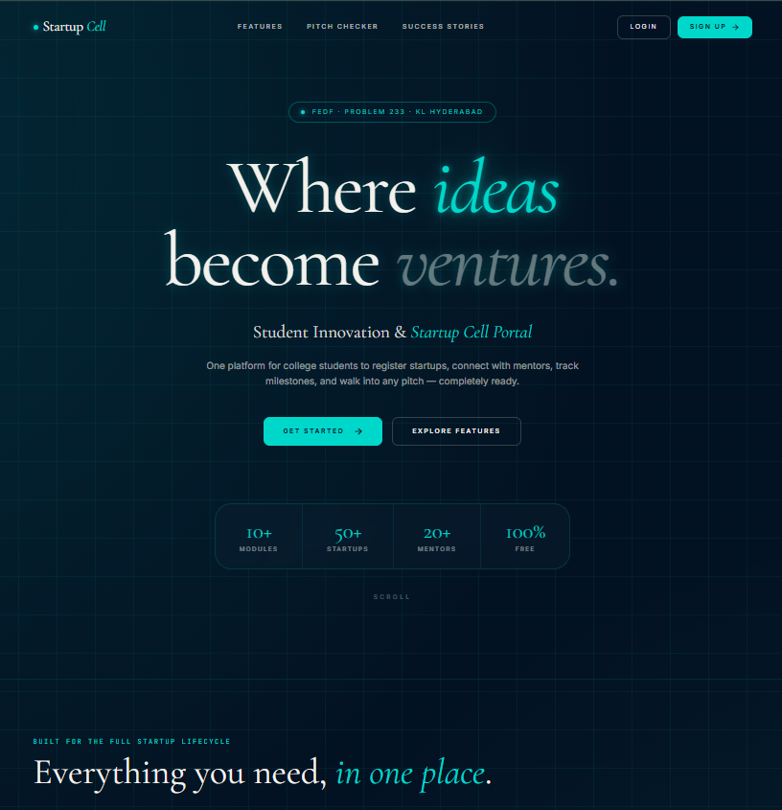

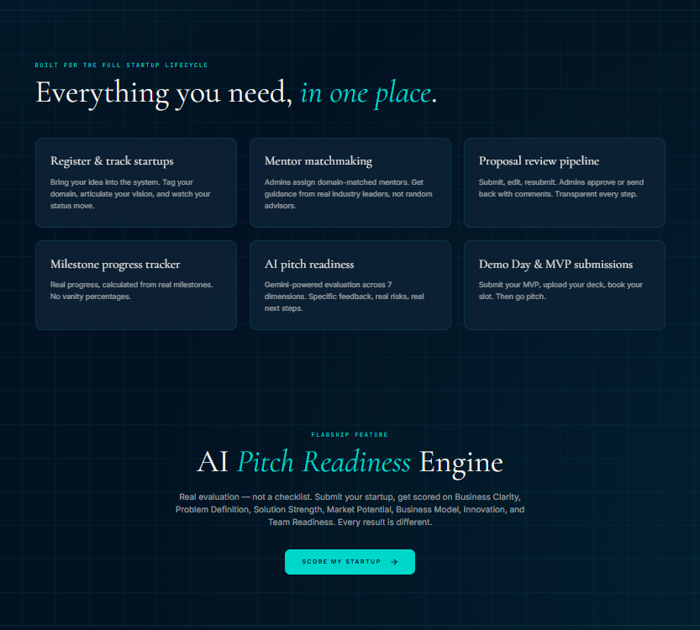

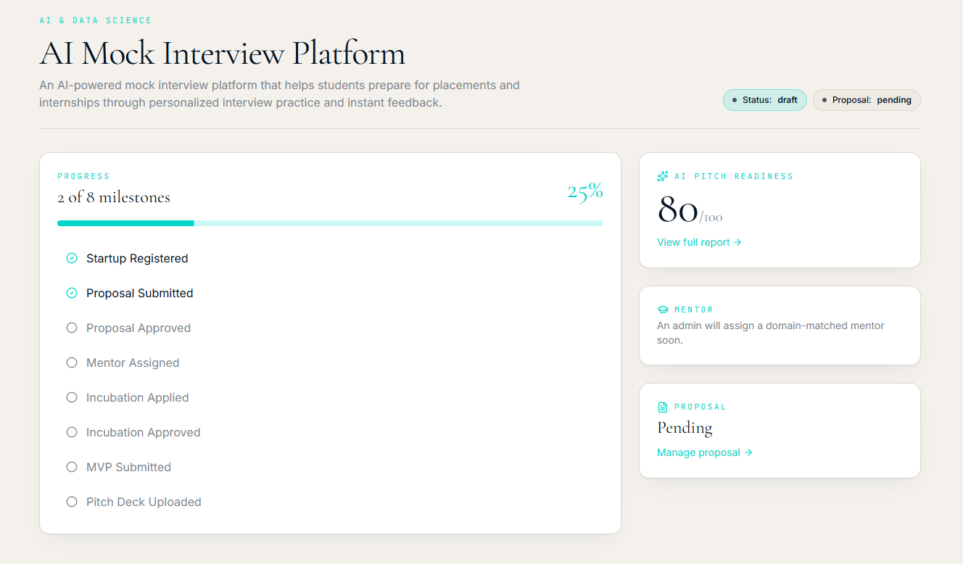

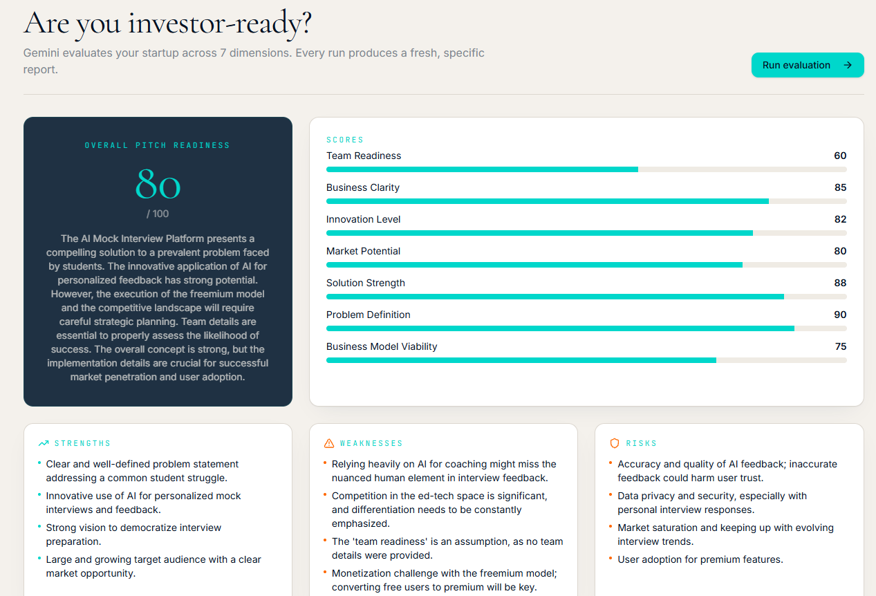

Sample code snippets

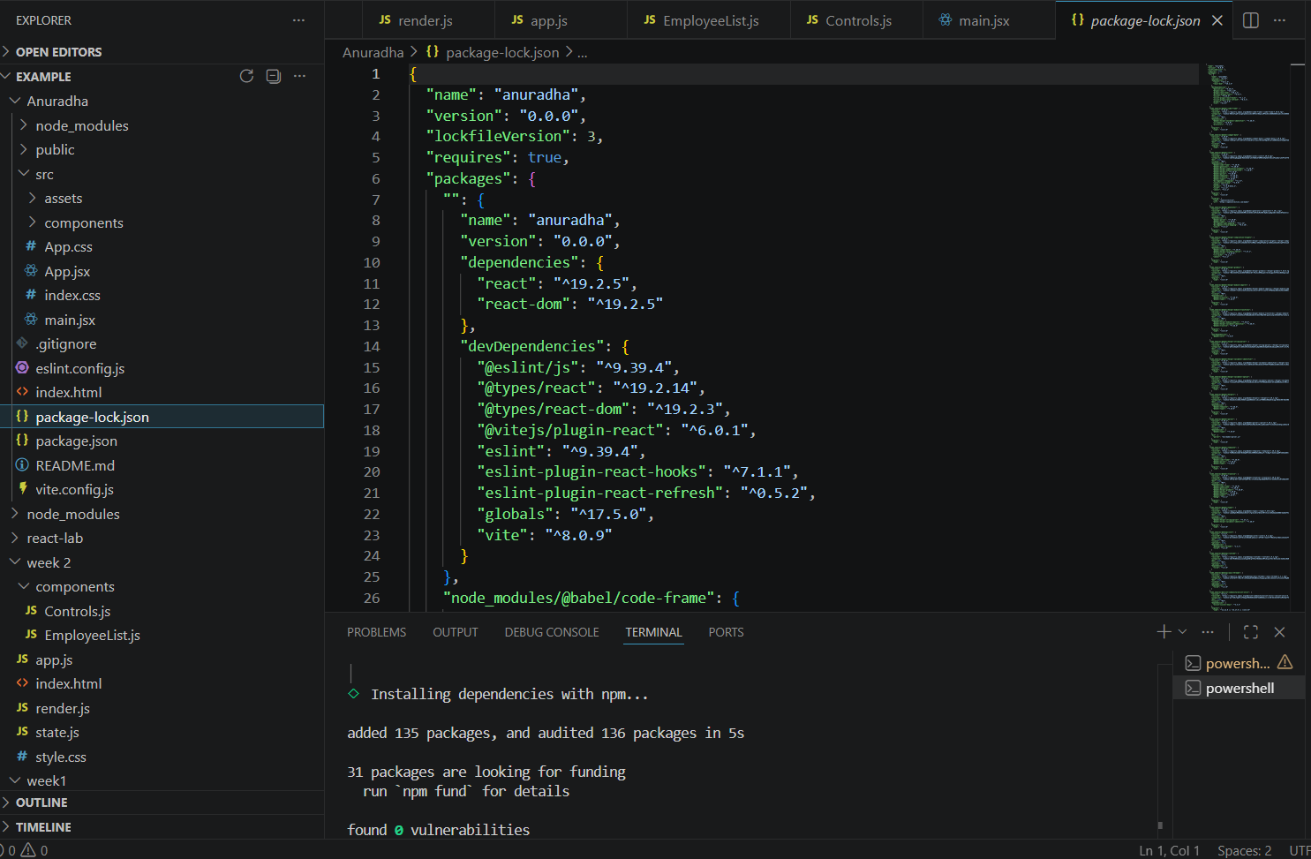

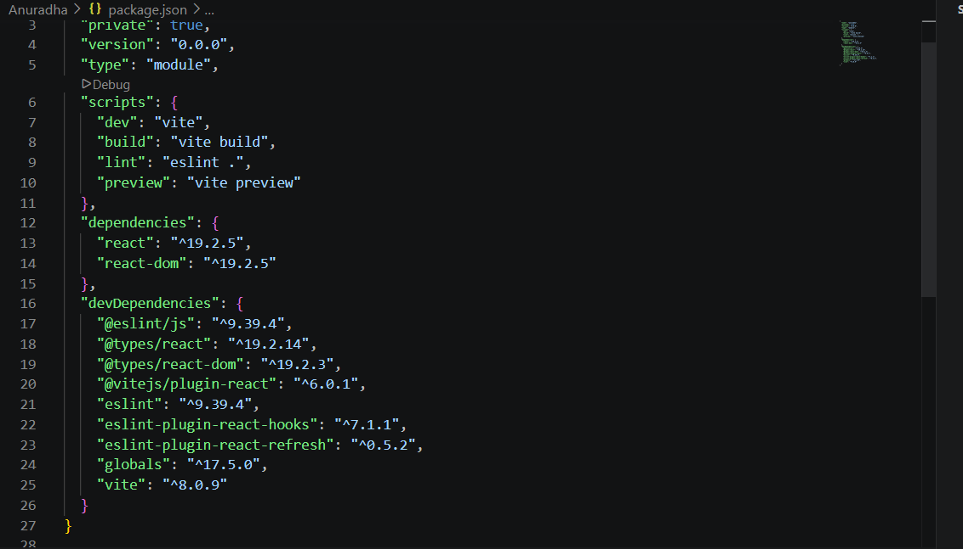
Installation/setup instructions

The GOglobe Integrated Tourism Platform is simple to install because it is built entirely using HTML, CSS, and JavaScript. It does not require any external frameworks or databases. The setup can be completed in just a few steps.

First, download or copy the complete Startupcell-portel project folder to your local computer. If it is shared as a ZIP file, extract it using any standard extraction tool. Make sure all files especially index.html, style.css, and script.js (if included) are in the same folder.

Next, open the folder in a text editor like Visual Studio Code or Sublime Text to review or modify the code. To run the project, simply double-click on the index.html file or right-click and select “Open with Browser.” The website will open and function in any modern browser such as Google Chrome, Microsoft Edge, or Firefox.

No installations or dependencies are needed. The project is fully self-contained and works offline, making it ideal for classroom demonstrations and educational submissions.

User manual or guide

When you open the Startup Cell-Portal platform, the homepage displays the main navigation bar with options like Login, Register. Users can begin by clicking the Login or Register buttons. A clean, half-page form will appear where users can enter their details to simulate login or registration.

Once logged into the Student Innovation & Startup Cell Portal, founders are welcomed with a personalized Founder Workspace Dashboard that provides a comprehensive overview of their startup journey. The dashboard displays essential information such as startup progress, proposal status, mentor updates, and AI Pitch Readiness Score in a clean and organized interface. Users can monitor milestone completion through a visual progress tracker, enabling them to clearly understand the current stage of their startup development, from registration and proposal submission to incubation and pitch preparation. The AI Pitch Readiness section presents an intelligent evaluation score along with access to a detailed analysis report, helping founders improve their business ideas before approaching mentors or investors. Dedicated modules such as My Startup, Proposal, Mentor, Pitch Prep, MVP, Demo Day, and AI Pitch Check allow users to efficiently manage every aspect of their entrepreneurial journey from a single platform. The dashboard also provides real-time notifications regarding mentor assignments and proposal reviews, ensuring users remain informed about important startup activities. The intuitive navigation, responsive layout, and interactive design provide a seamless user experience, demonstrating how a modern digital Startup Cell Management System can effectively support innovation, collaboration, and entrepreneurial growth within educational institutions.

